Product Configuration Design for OpenWay Collection Engine
Smart Energy Project - Release 4a
Consumers Energy
Author: Itron Professional Services
Date: November 10, 2014
Version: 1.0
Table of Contents

A. Document Controls 3
A.1. Change Record 3
A.2. Reviewers 3
A.3. Document Storage 3
A.4. Document Owner 3
B. About this Document 4
B.1. Document Purpose 4
B.2. References 4
C. Server Environment 5
C.1. Servers 5
D. Installation 7
D.1. Installation Details 7
E. Configuration 9
E.1. Assumptions 9
E.1.1. Release 4a 9
E.2. Configuration Details 9
E.2.1. TNSNames.ora 10
E.2.2. Server Pool 11
E.2.3. Transport Mode and Device Types 12
E.2.4. Windows Certificates 13
E.3. Collection Engine Manager 14
E.3.1. Web Services Configuration Utility 14
E.3.2. OpenWay Collection Engine Manager System Utilities 25
E.4. Collection Engine UI Website 31
E.4.1. Time Zone 32
E.5. Meter Program 33
E.6. Web Service Validation 50
E.7. Security Settings 57
E.8. HSM Manager Install 61
E.9. ISM Config: 63
E.9.1. nCipher CSP Install Wizard 63
E.9.2. Itron Security Manager Configuration 64
E.9.3. 69
E.9.4. Metadata for Service Instances 69
F. Open Issues and Questions 71

Document Controls

Change Record
Date | Author | Version | Change Reference
12/03/14 | Ed Abranovich | 1.0 | Approved Baseline Work Product
11/10/14 | Hayden Shepherd | 0.1 | Created for Dev, QA, and PreProd

Approvers/Reviewers
Name | Sign-off? | Position
Debbie Harworth | Yes | Critical Infrastructure Manager
Hayden Shepherd | Yes | Itron Implementation Manager
Jeff Sprengel | Yes | Consumers Energy Head End PM

Document Storage
This document was created using MS Word and is stored in the project SharePoint site.

Document Owner
This document contains information that is confidential and proprietary to Itron, who is the owner and responsible for developing and maintaining this document. It is understood that this document is for the purposes of the Smart Energy Project - Release 4a with the expectation that there will be updates for subsequent releases. This document, or portions thereof, should not be referred to, distributed or utilized in any other way outside of the project’s needs without prior approval of Itron.

About this Document

Document Purpose
This document provides the following:
- The configuration and necessary procedures to build and /or rebuild the OpenWay solution production system
- Screen shots to illustrate specific configurations
- This is not intended to be Training Material nor a User Manual
- Please note that this document provides the configuration details for the current environment to support only this release and may change in subsequent project phases.
- NOTE: This document does not yet include configurations for ISM server, which will be added at a later date.
- NOTE: This document is currently in a DRAFT form status, which means specific configurations are placeholders only and will all need to be updated to reflect environmental information. The final version will be delivered after go live to allow Itron to document all configurations.

References
The following terms or phrases will be referenced in this document:
- OWCE – Itron OpenWay Collection Engine
- Openway CS App Server
- Openway CE Tools Server
- ISM – Itron Security Manager
- Thales Security
- AMI Service Test
- CENTRON Key Injector
- DSI Test
- Net Table Reader Console
- Socket Server
- PuTTY
- TFTP
- Wireshark
- Syslog
- WinSCP
- Itron Meter Simulator

Server Environment
This section describes the production server environment configuration.

Servers
OpenWay CE App Servers
Area | Details | Comments
Server Names (Environment) | OWCEDEVAPP (DEV)  OWCEQAAPP1 (QA)  OWCEQAAPP2 (QA)  OWCEPREAPP1 (PreProd)  OWCEPREAPP2 (PreProd)  OWCEPREAPP3 (PreProd)  OWCEPREAPP4 (PreProd)  OWCEPRODAPP1 (Prod)  OWCEPRODAPP2 (Prod)  OWCEPRODAPP3 (Prod)  OWCEPRODAPP4 (Prod)  OWCEDRAPP1 (DR)  OWCEDRAPP2 (DR)  OWCEDRAPP3 (DR)  OWCEDRAPP4 (DR) | Physical Machines
Domain | EMS
Operating System | Windows 2012 Enterprise R2 64 bit w/.NET 4.5
DB |  | Not Applicable

OpenWay CE Tools Server
Area | Details | Comments
Server Name (Environment) | OWCESIM (PreProd) | Physical Machine
Domain | EMS
Operating System | Windows 2012 Enterprise R2 64 bit w/.NET 4.5
DB |  | Not Applicable

OpenWay ISM App Servers
Area | Details | Comments
Server Names (Environment) | ISMDEVAPP (DEV)  ISMQAAPP (QA)  ISMPREAPP (PreProd)  ISMPRODAPP (Prod)  ISMDRAPP (DR) | Physical Machines
Domain | EMS
Operating System | Windows 2012 Enterprise R2 64 bit w/.NET 4.5
DB |  | Not Applicable

Thales Security Appliances
Area | Details | Comments
Server Names (Environment) | Testing1 (DEV, QA, PreProd)  TESTING2 (DEV, QA, PreProd)  PROD1 (Prod, DR)  PROD2 (Prod, DR) | Appliances w/ Failover capability
Domain
Operating System | Proprietary
DB |  | Not Applicable

Database Server
Area | Details | Comments
Server Name (Environment) | NONPRIMEDB (QA, DEV PREPROD)  PROD  DR | Physical Machine
Domain
Operating System | Oracle Enterprise Linux 6.4 64 bit
DB | Oracle 11.2.0.3 64 bit

Installation
This section describes the installation directory, settings, and applications.

Installation Details
OpenWay CE App Server
Area | Details | Comments
OpenWay CE Install Directory | D:\AMI\ | SR6.5
Oracle Client | D:\Oracle | 11.1.0.7.0 64 bit
AMI Service Test | D:\AMI\
Database Machine Name | NONPRIMEDB  PRIMEDB
Database Service Name | OWCEDEV, OWCEQA, OWCEPRE
Database Protocol | TCP
Database Port | 1522, 23, 24, 25, etc.
Database Alias | OPENWAY
Database Schema Owner | AMI

OpenWay CE Tools Server
Area | Details | Comments
OpenWay CE Install Directory | D:\AMI\
AMI Service Test | D:\AMI\
CENTRON Key Injector | D:\AMI\
DSI Test | D:\AMI\
Net Table Reader Console | D:\AMI\
Socket Server | D:\AMI\
PuTTY
TFTP
Wireshark
Syslog
WinSCP
Itron Meter Simulator | D:\Simulator | Version 6.0.0.0.1525
Oracle Client | D:\Oracle | 11.1.0.7.0 64 bit
Oracle Patch Set | D:\Oracle
Database Machine Name
Database Service Name
Database Protocol | TCP
Database Port | 1521
Database Alias | OPENWAY
Database Schema Owner | AMI

OpenWay ISM App Server
Area | Details | Comments
OpenWay CE Install Directory | D:\... | 2.0.0.130
Oracle Data Access Components | D:\Oracle | 11.2.0.3.20 64 bit Patch 21
Database Machine Name | ISMNONPRIMEDB,  ISMPRIMEDB
Database Service Name | ISMDEV, ISMQA, ISMPRE
Database Protocol | TCP
Database Port | 1522, 23, 24, 25, etc.
Database Alias | ISMDEV, ISMQA, ISMPRE
Database Schema Owner | ISMUser

Configuration
This section describes CE configurations for the project.

Assumptions
Following are the assumptions were used when configuring CE Release 4a Environments

Release 4a
- Only one meter configuration has been created by Consumers: Residential 2001
- Each OWCE server can handle up to 400,000 direct connect cellular ITRJ meters only.
- The pool of servers is scaled to handle 1,000,000 meters with one extra for failover.
- All servers are Physical (i.e., no Virtual Machines).
- The web services security model assumes one-way SSL with username/password over transport.

Configuration Details
The following configuration sub sections explain the Smart Energy Project - Release 4a configurations. Most of the configurations are accompanied with a screen shot for cross reference. However, any configurations that are not included in this document remain with its default values.

TNSNames.ora
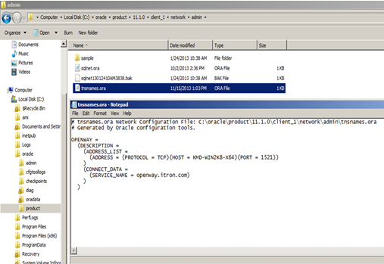
Figure 1 – TNSNAMES.ORA
Validate NLS Character Set:
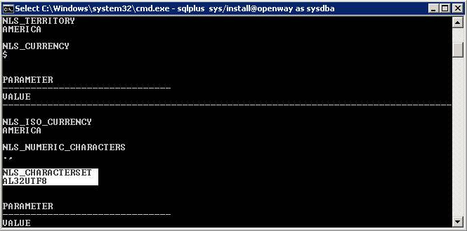
Figure 2 – NLS Character Set

Server Pool
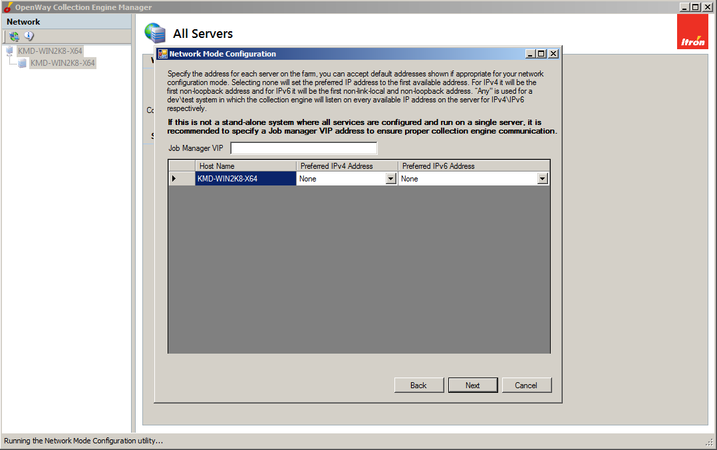
Figure 3a – Servers and VIP
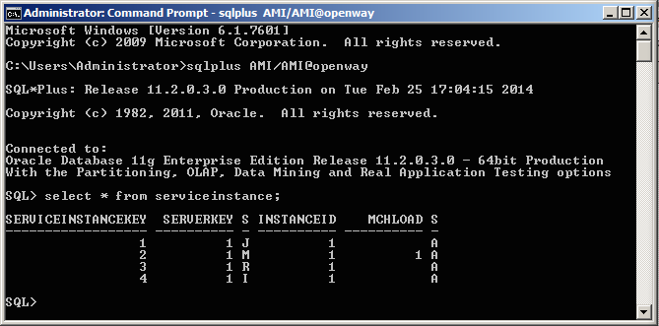
Figure 3b – Service Instance

Transport Mode and Device Types
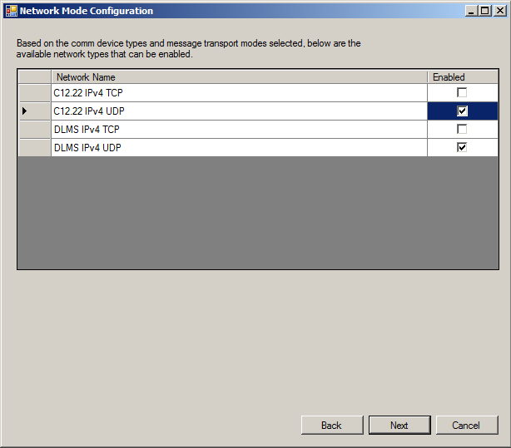
Figure 4 – Transport Mode
Screenshot
Figure 5 – Device and Message Types
Screenshot

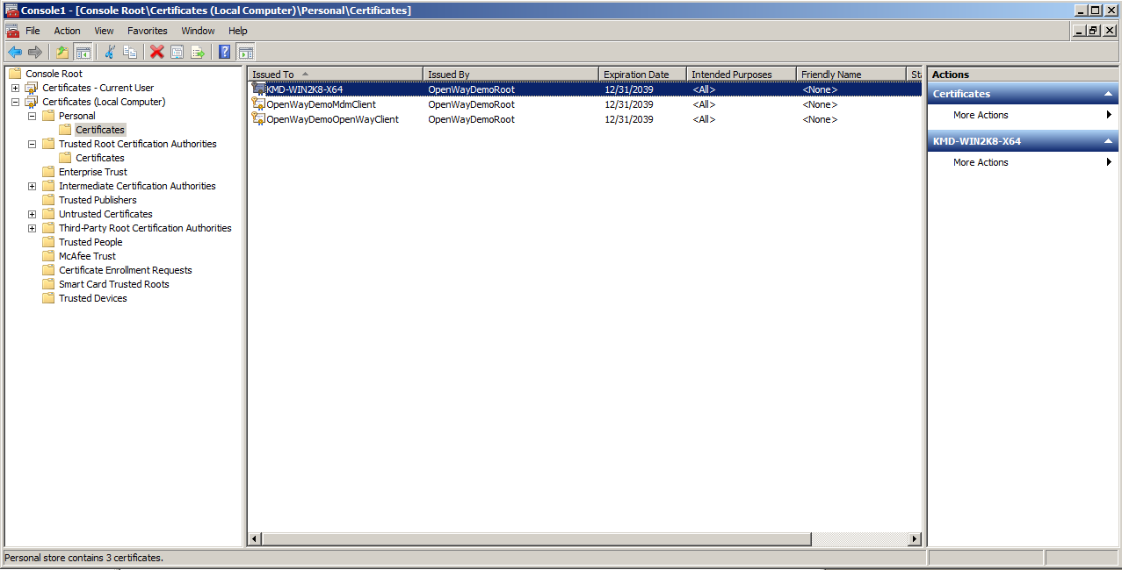
Windows Certificates
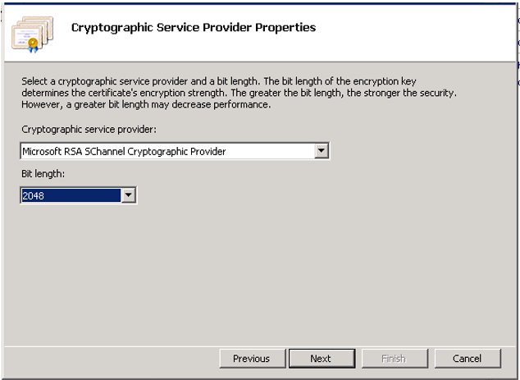
Figure 6 – Root Cert
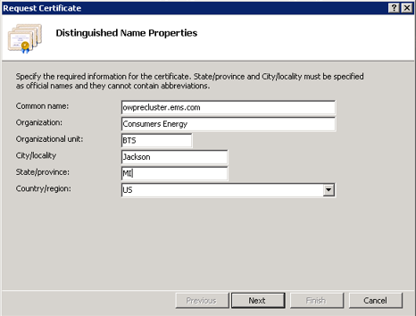
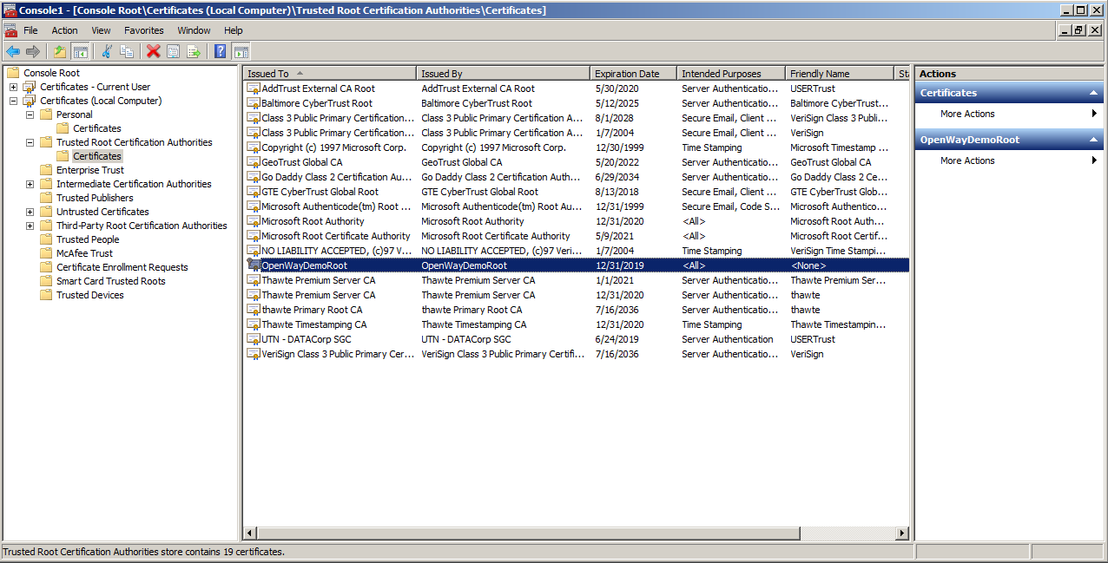
Figure 7 – Windows Cert

Collection Engine Manager
To launch the OpenWay Collection Engine Manager
After installing the OpenWay Collection Engine software, click Configure in the Collection Engine Installer.
Or
1. Navigate to the Bin folder, and right-click CollectionEngineManager.exe.
2. Select Run as Administrator.

Web Services Configuration Utility
To open the Web Service Security Configuration Utility
1. In the Network pane, select the top-level item in the tree. The Web Service Security Configuration settings apply system-wide and not to a specific server.
2. Click Web Service Security Configuration

Address Settings
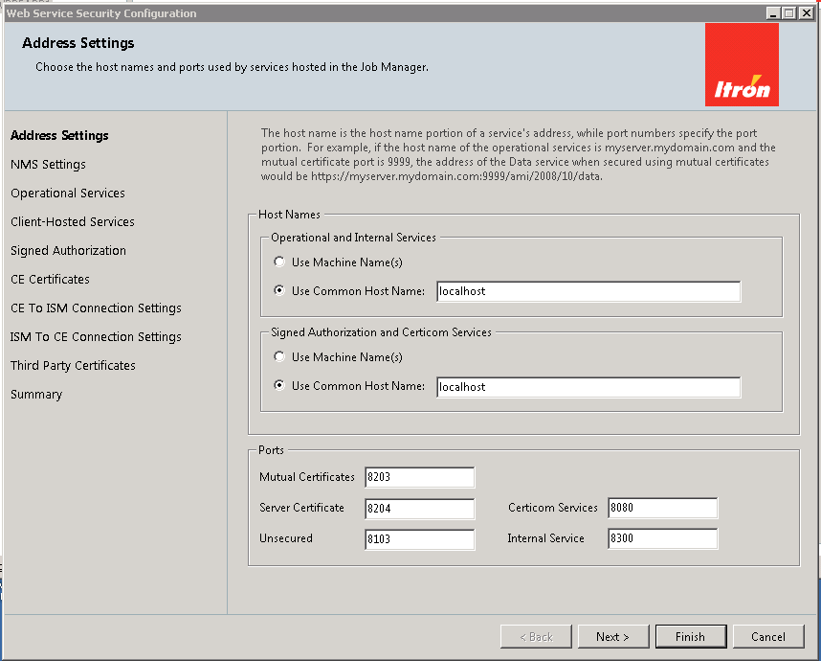

NMS Settings
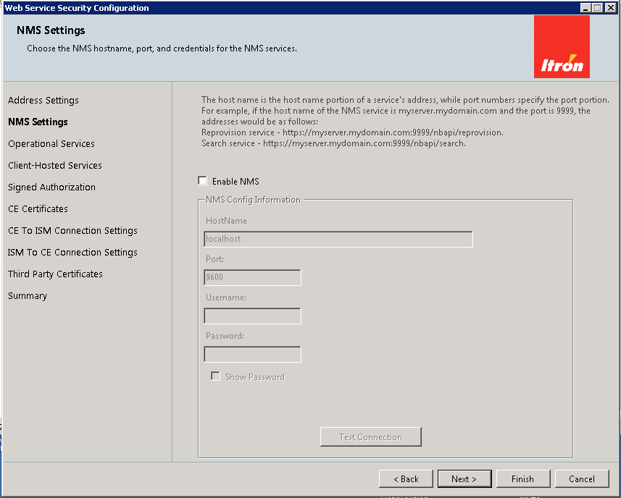

Operational Services
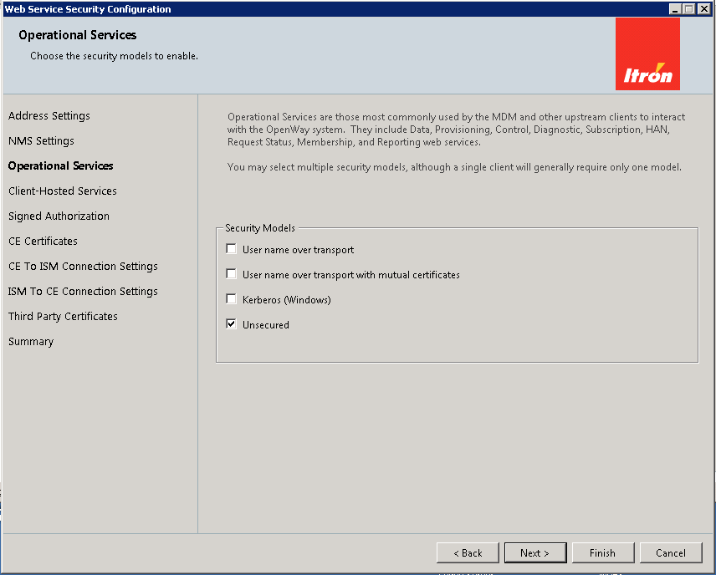

Client-Hosted Services
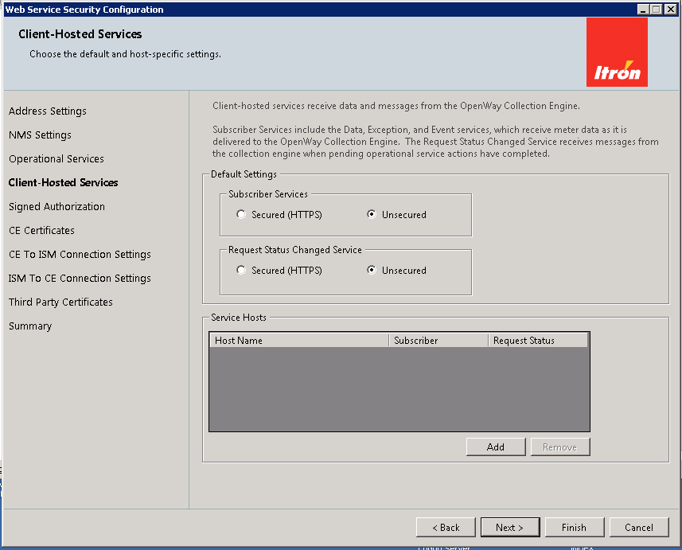

Signed Authorization
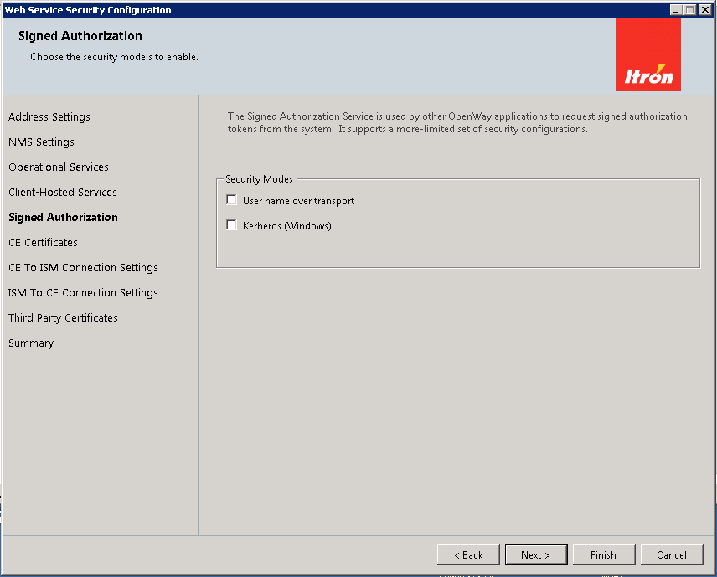

CE Certificates
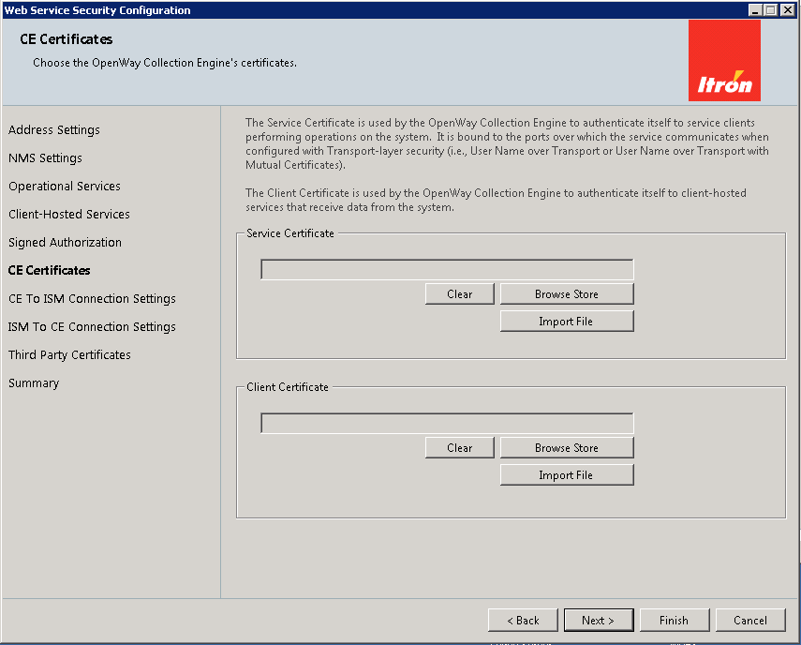

CE to ISM Connection Settings. Itron Security Manager (ISM)
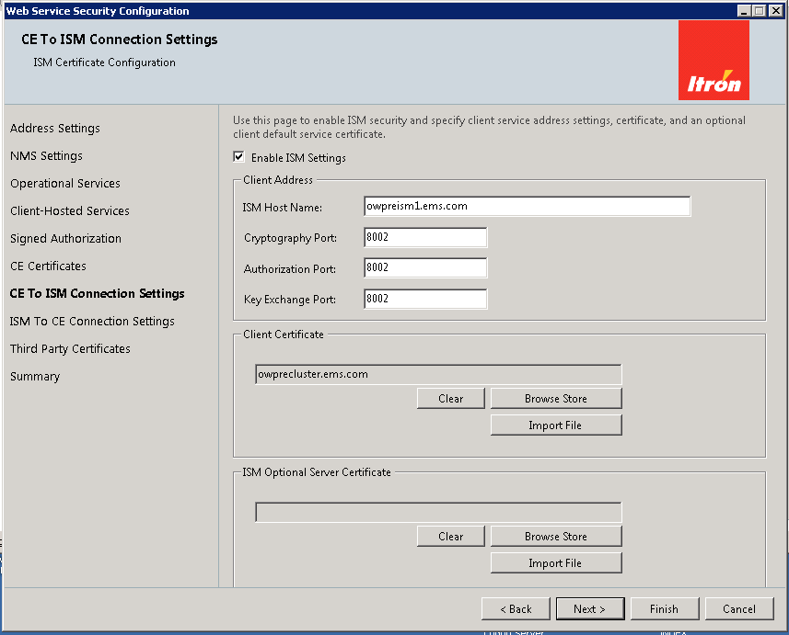
- Enter the FQDN of the VIP in the common host name field. Use Port 8082.
- Select the OWCE Server Cert again.
- During the ISM setup, you should have exported the ISM client cert. Import it into the OWCE setup screen.

ISM to CE Connection Settings. Itron Security Manager (ISM) configuration
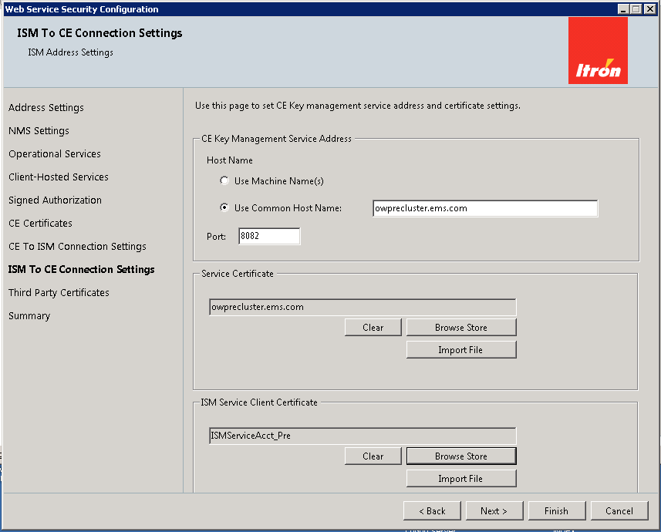

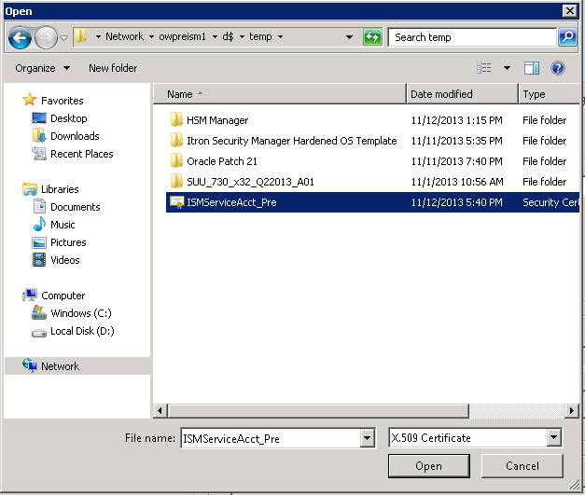

Third Party Certificates. Installs third-party certificates
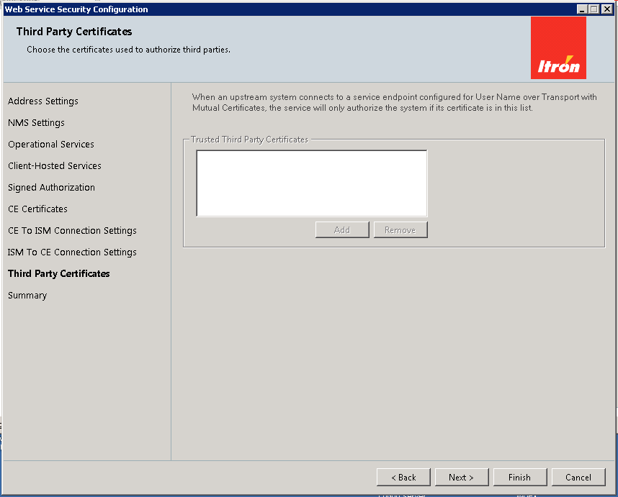

Summary
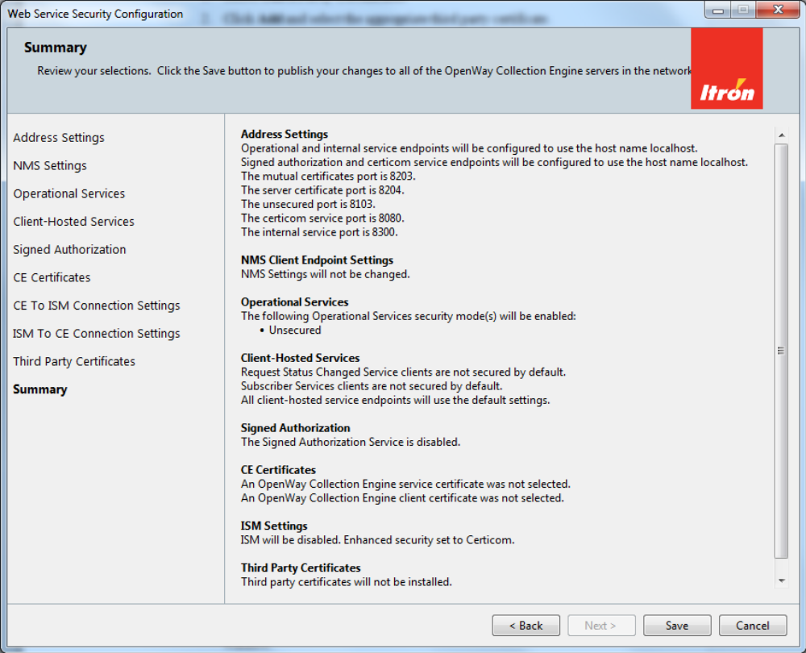
To apply your Web Service Security configuration
- Review your selections on the Web Services Security Configuration Summary window.
- If the settings are correct, click Save.
- If one or more settings are not correct, do the following:
- Click the appropriate setting in the menu pane on the left.
- Make necessary corrections.
- Click Finish.
- Repeat Steps a through c for each additional correction (if required).
- Click Summary,

OpenWay Collection Engine Manager System Utilities

Logging
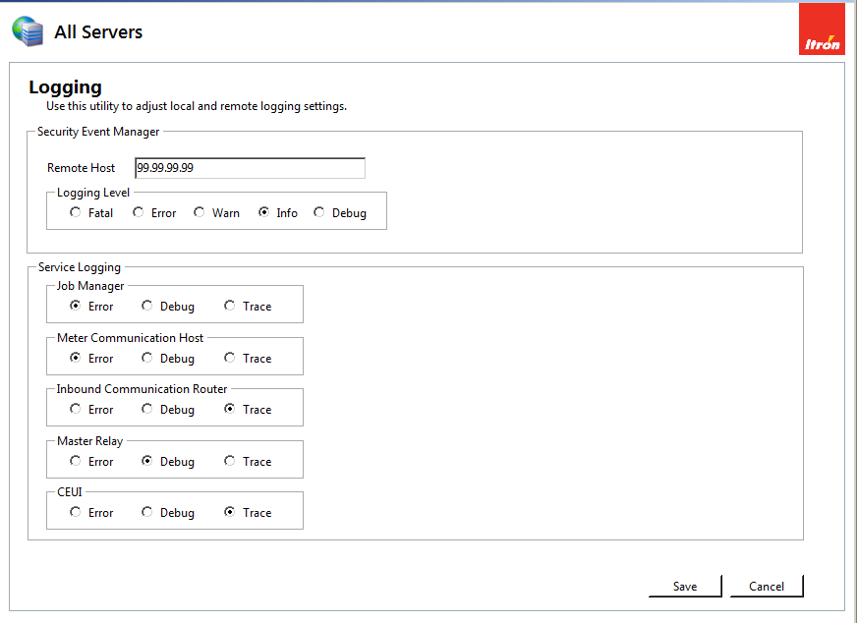

Network Mode Configuration
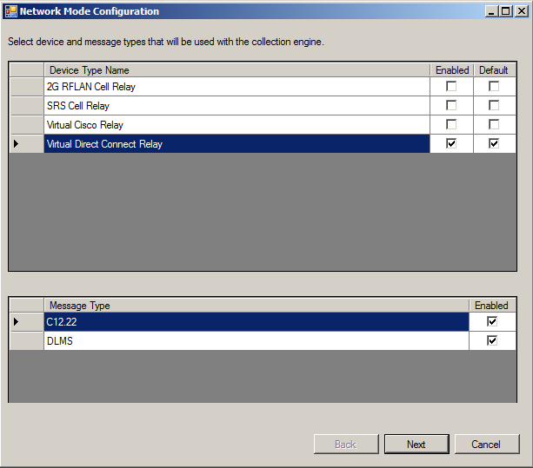
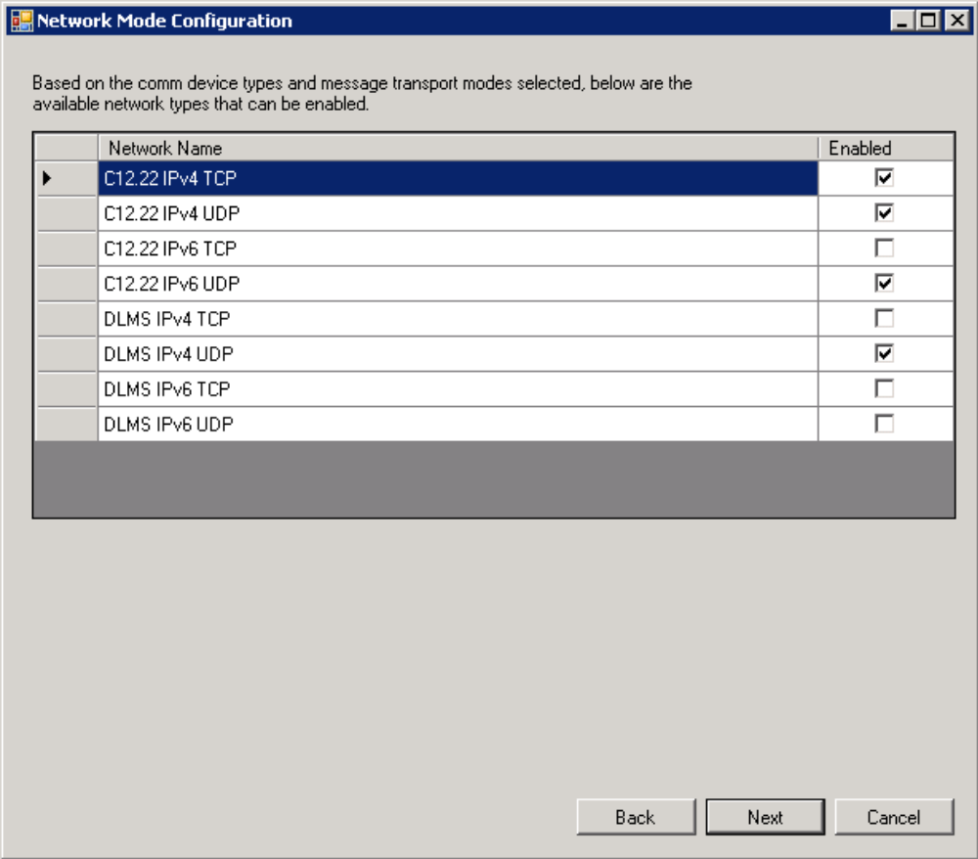
select value from setting where settingname = 'JobManagerVIP';
Add VIP
Update setting set value = '10.26.236.153' where settingname = 'JobManagerVIP';
Commit;

Plug-Ins
Not certain there are any plug-ins.

Wakeup
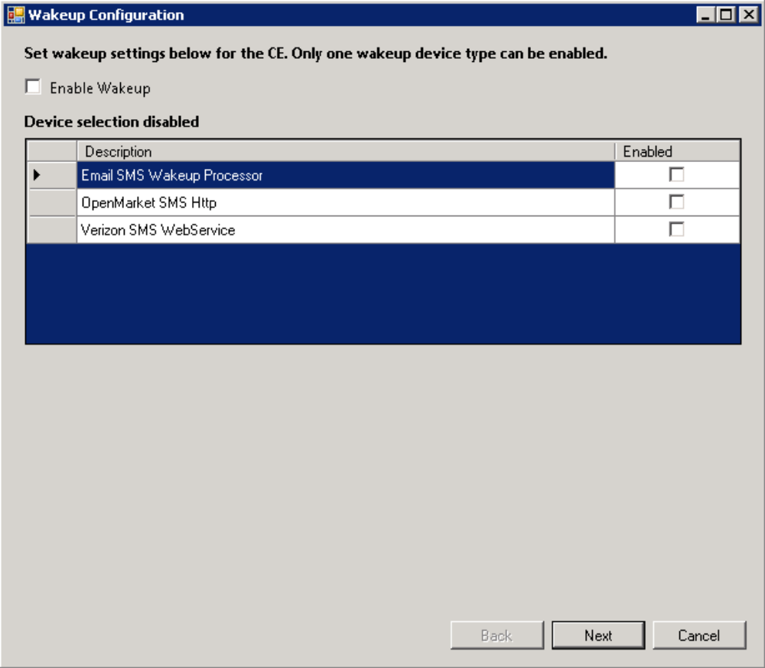
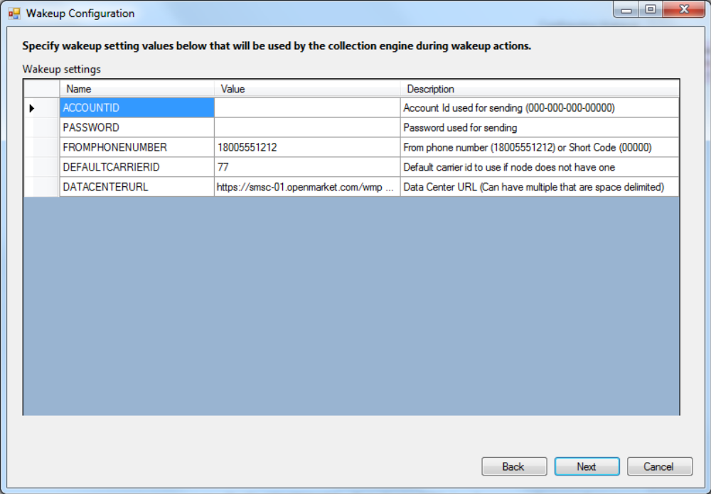
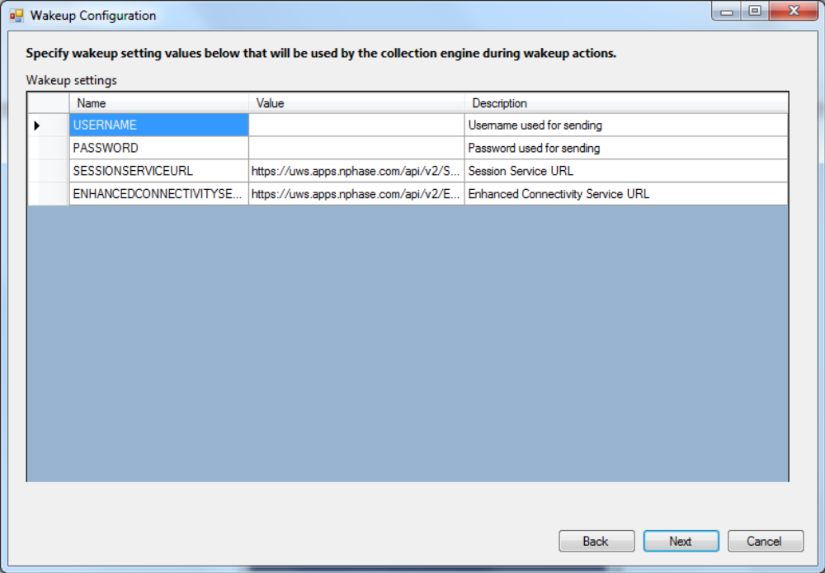

Collection Engine UI Website
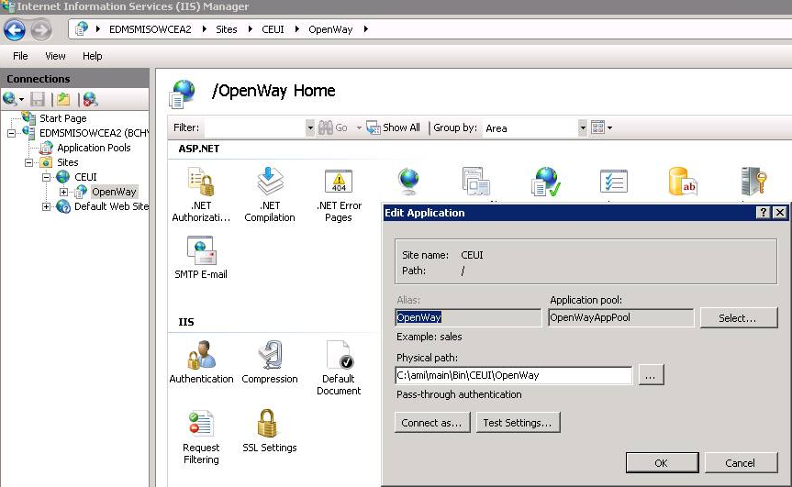
Figure 12 – CEUI Install Directory

Time Zone
System Wide
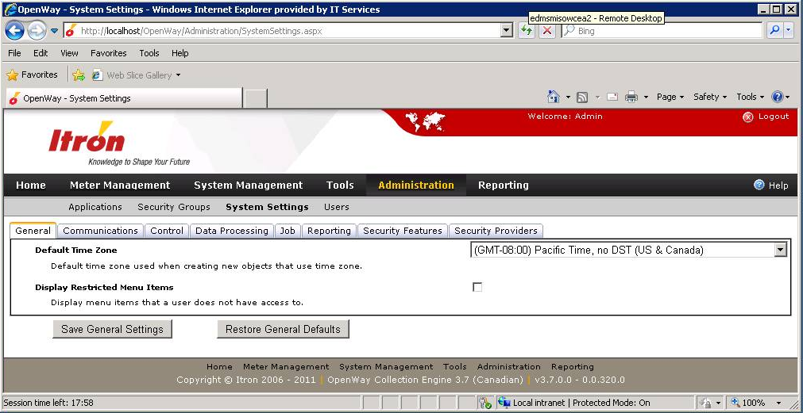
Figure 13 – Global Time Zone Default
Existing User
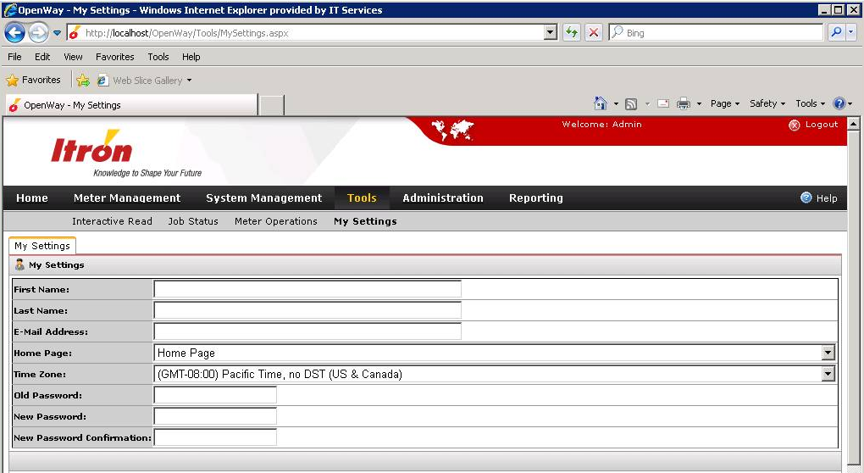
Figure 14 – User Time Zone

Meter Program
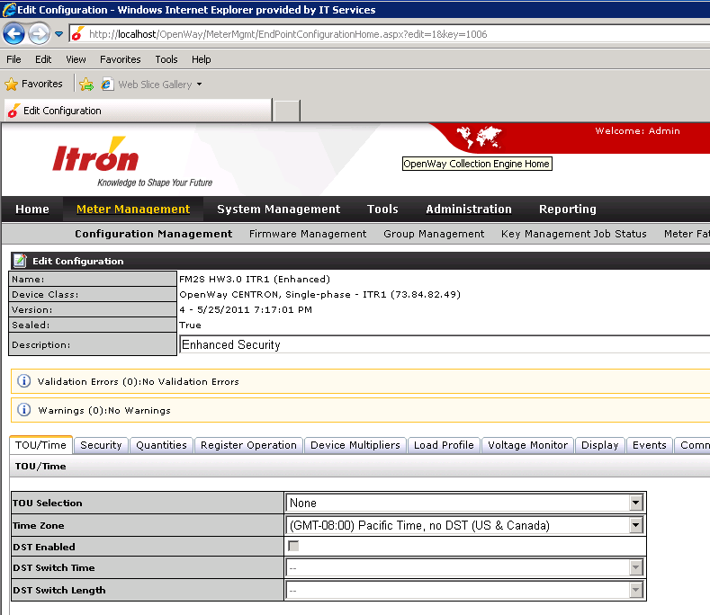
Figure 15 – Meter Program TOU/Time Tab

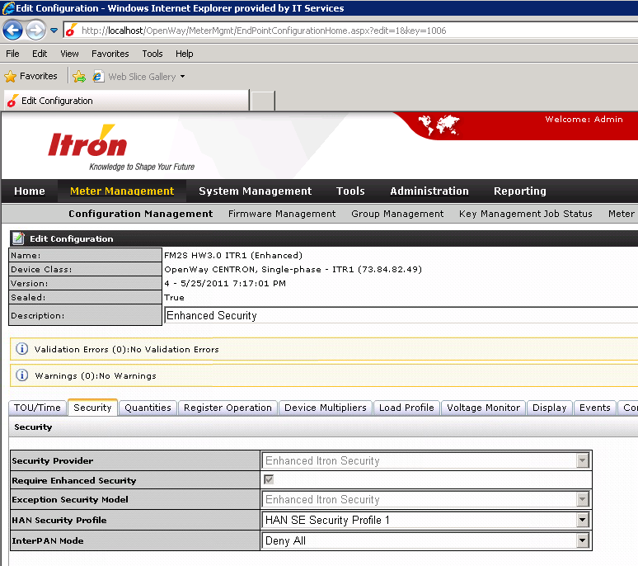
Figure 16 – Meter Program Security Tab
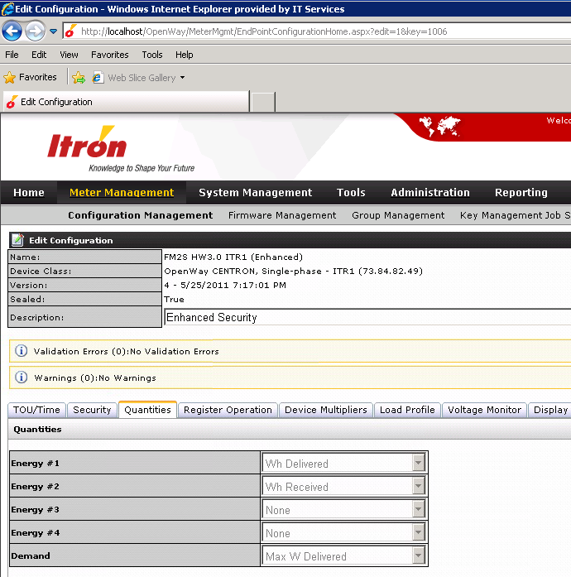
Figure 17 – Meter Program Quantities Tab

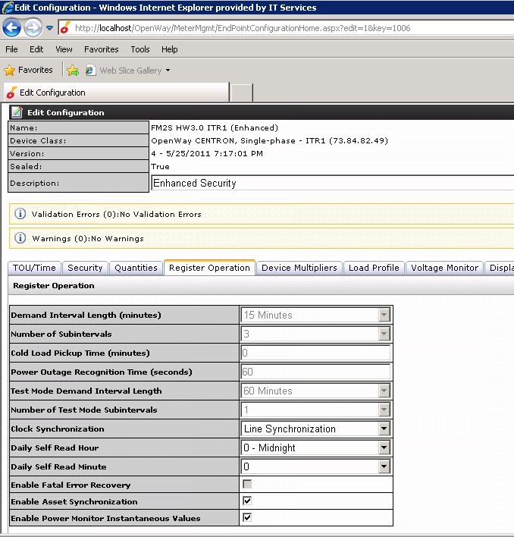
Figure 18 – Meter Program Register Operation Tab
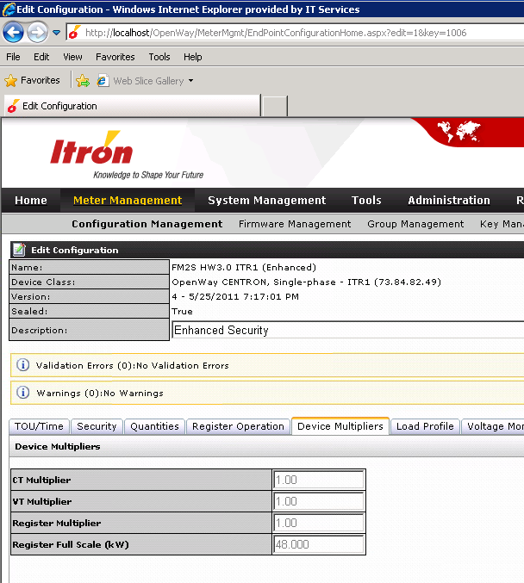
Figure 19 – Meter Program Device Multipliers Tab

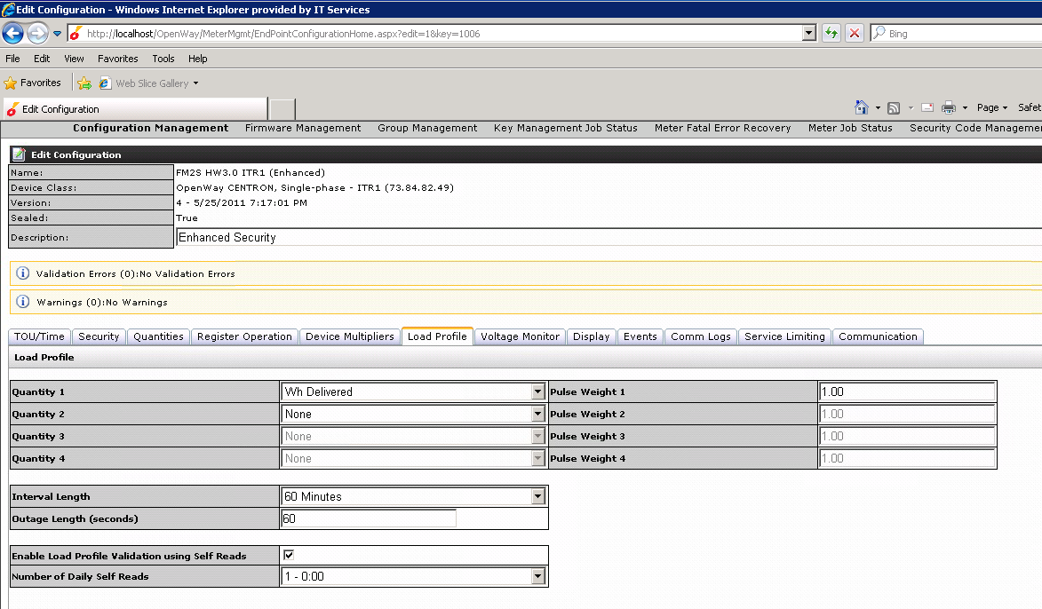
Figure 20 – Meter Program Load Profile Tab

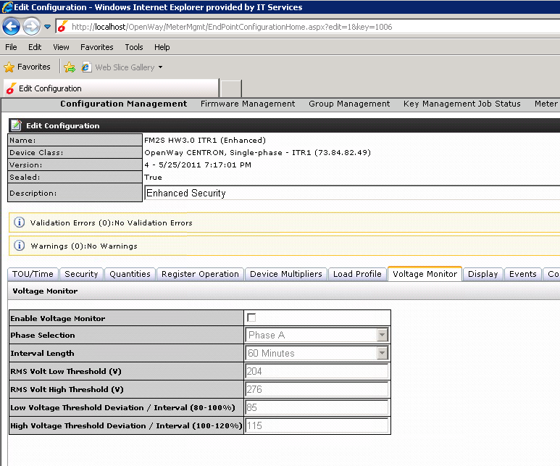
Figure 21 – Meter Program Voltage Monitor Tab

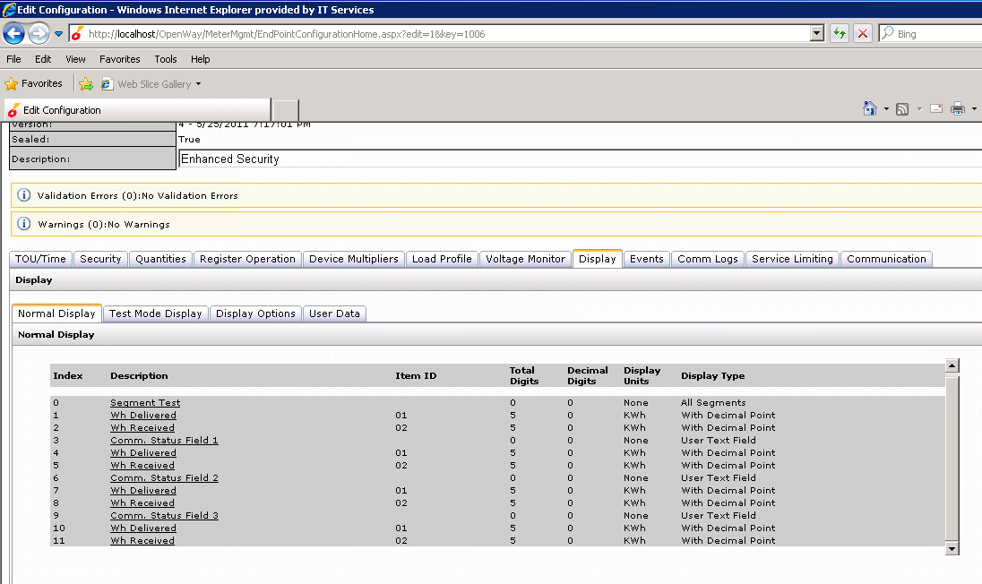
Figure 22 – Meter Program Normal Display Tab

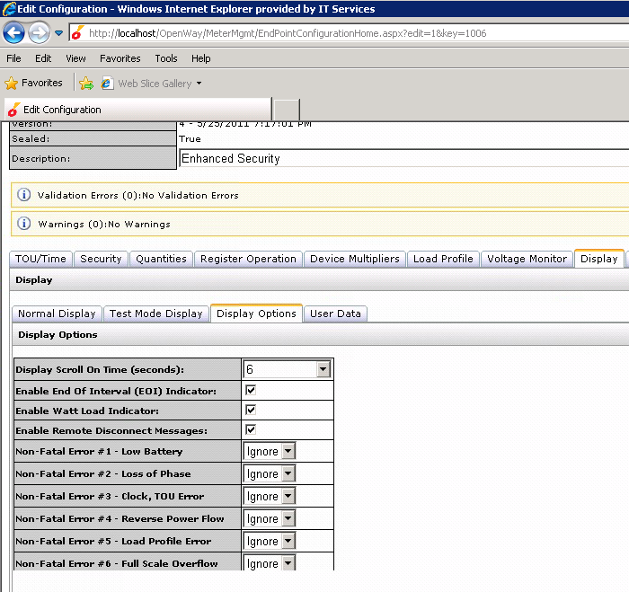
Figure 23 – Meter Program Display Options Tab

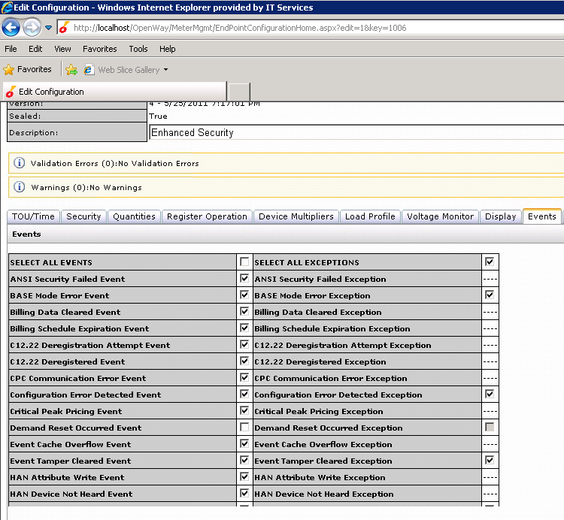
Figure 24-1 – Meter Program Events Tab
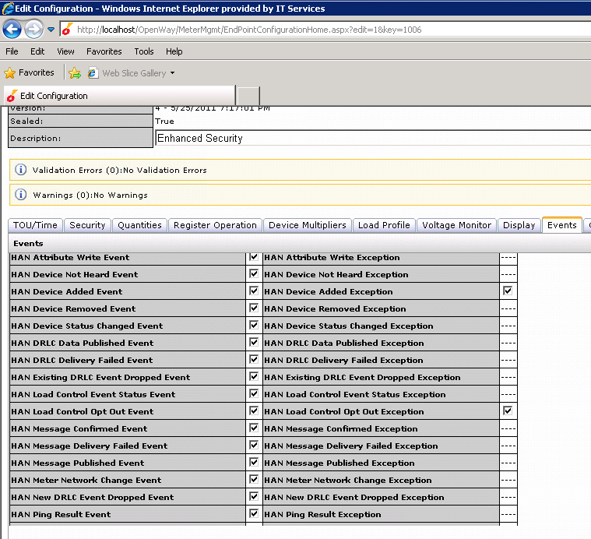
Figure 24-2 – Meter Program Events Tab
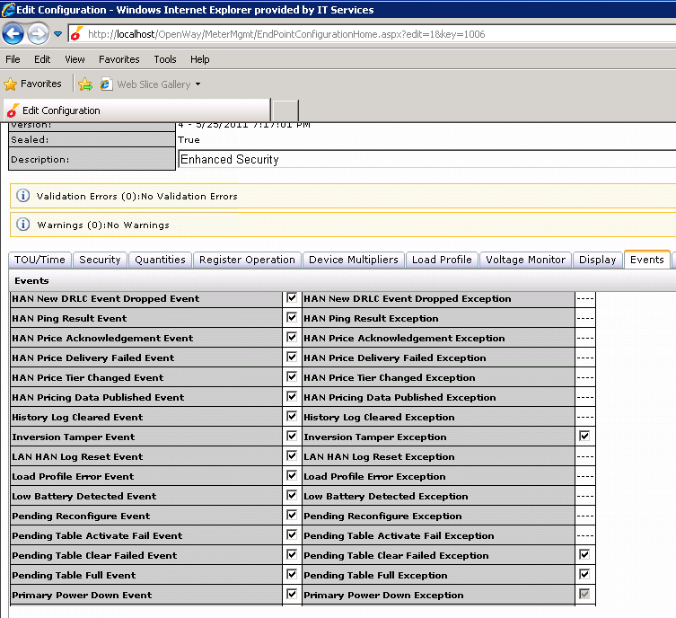
Figure 24-3 – Meter Program Events Tab
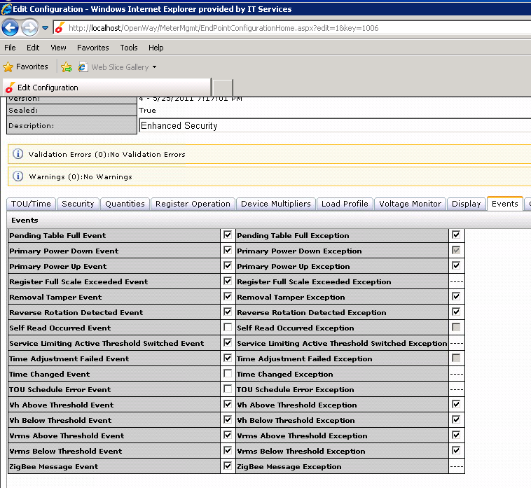
Figure 24-4 – Meter Program Events Tab
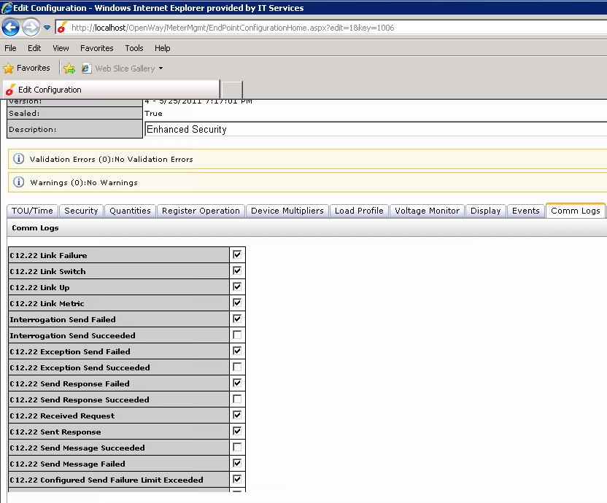
Figure 25-1 – Communication Logs Tab
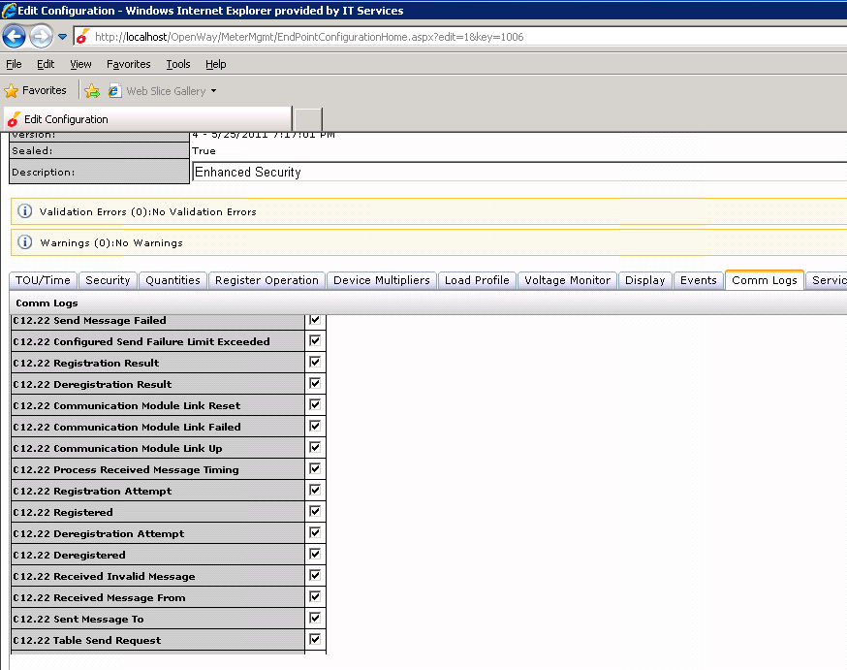
Figure 25-2 – Communication Logs Tab
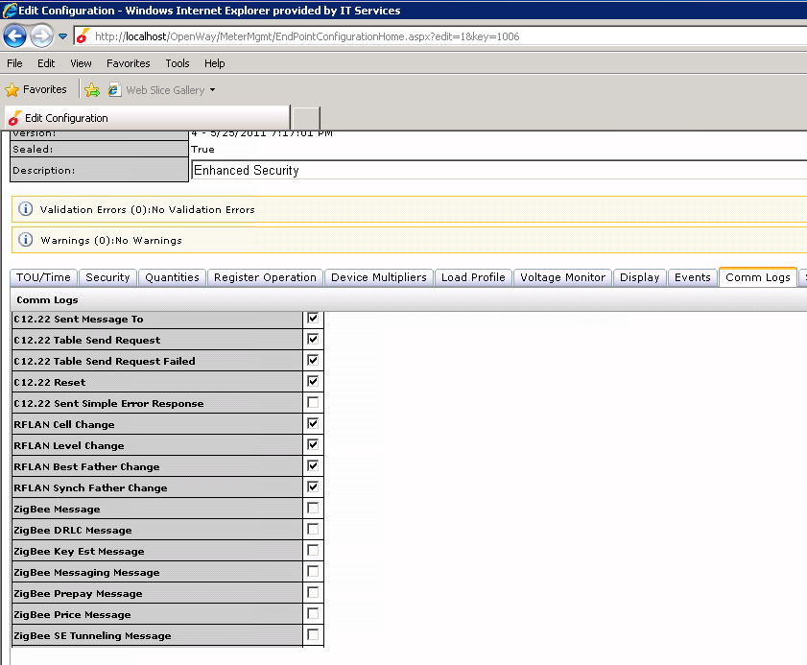
Figure 25-3 – Communication Logs Tab

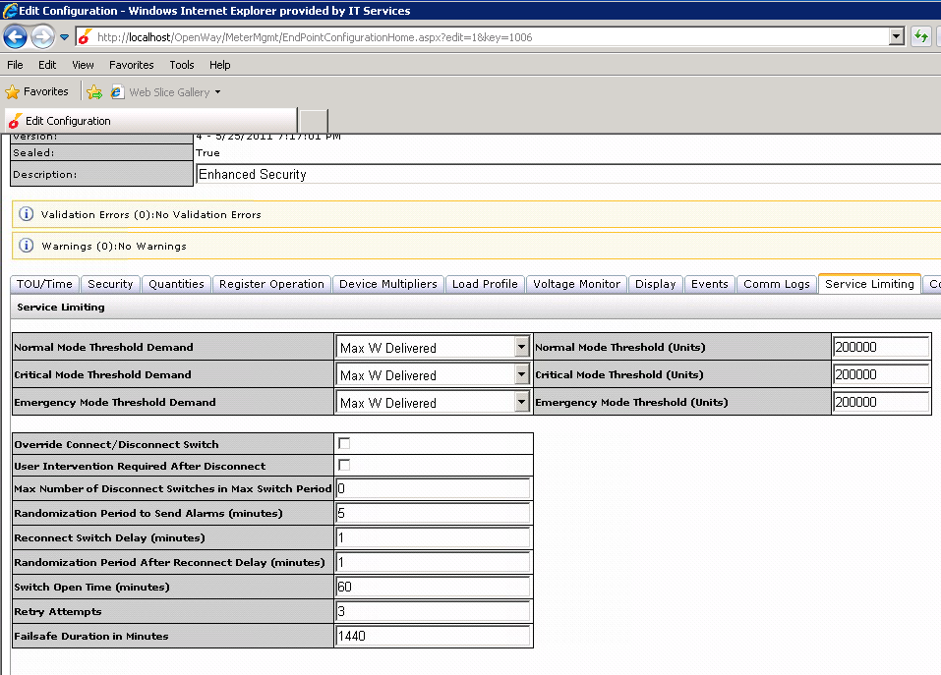
Figure 26 – Meter Program Service Limiting Tab

Web Service Validation
Between edmsmisowcea2 (Application Server) and edmsmisowcet2 (Tools Server)
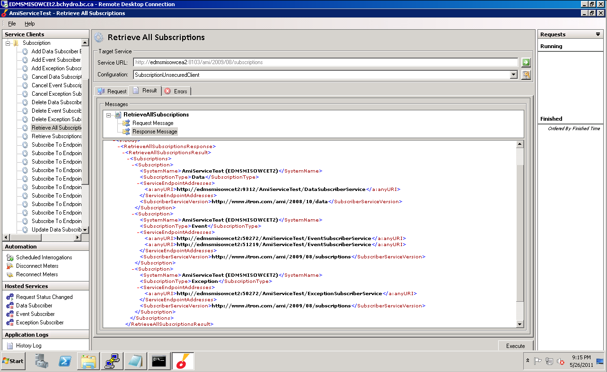
Figure 26 – AMI Service Test

Control Service WSDL 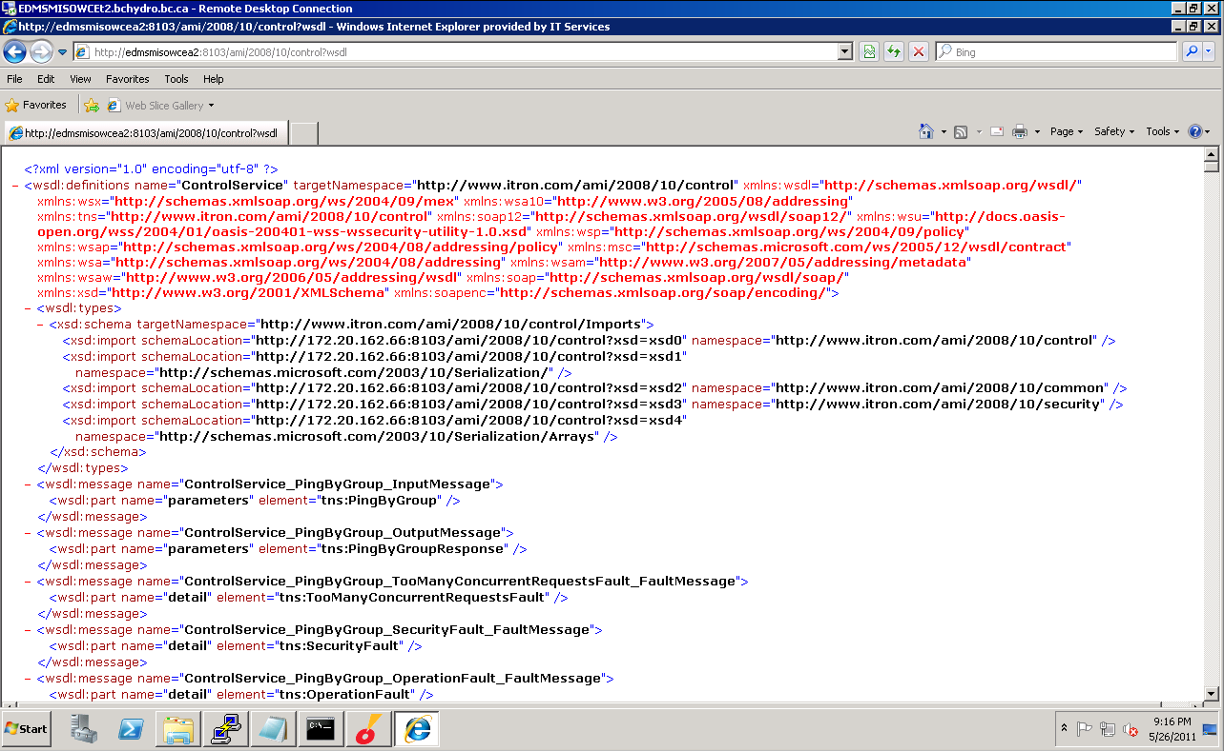
Figure 27 – Control Service WSDL
DataService WSDL 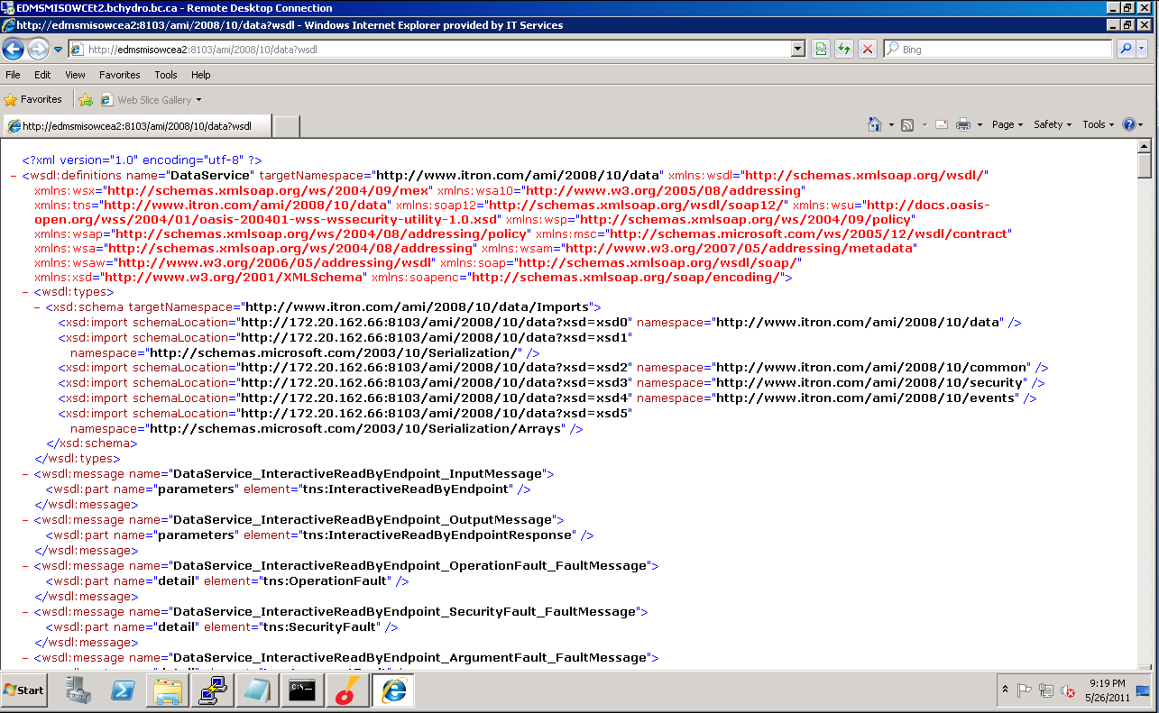
Figure 28 – DataService WSDL
HAN Service WSDL 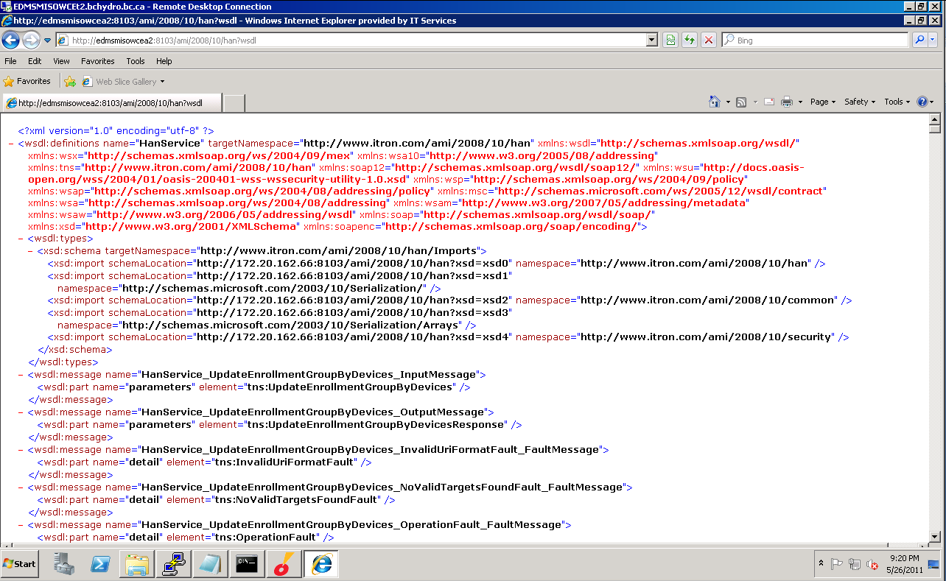
Figure 29 – HAN Service WSDL
Membership Service WSDL 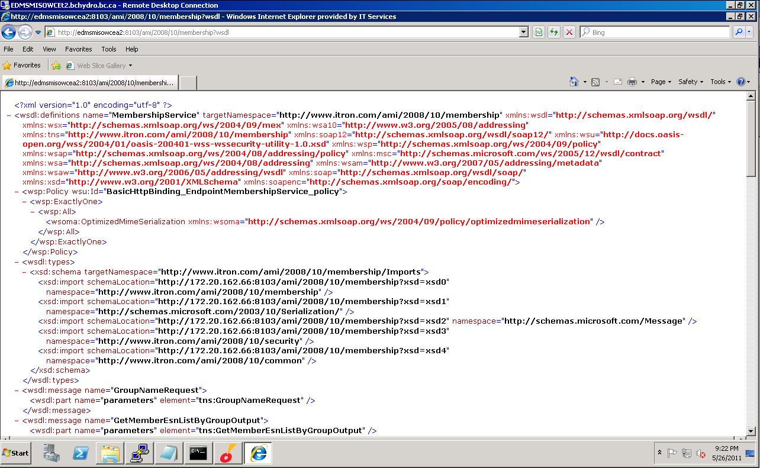
Figure 30 – Membership Service WSDL
Provisioning Service WSDL 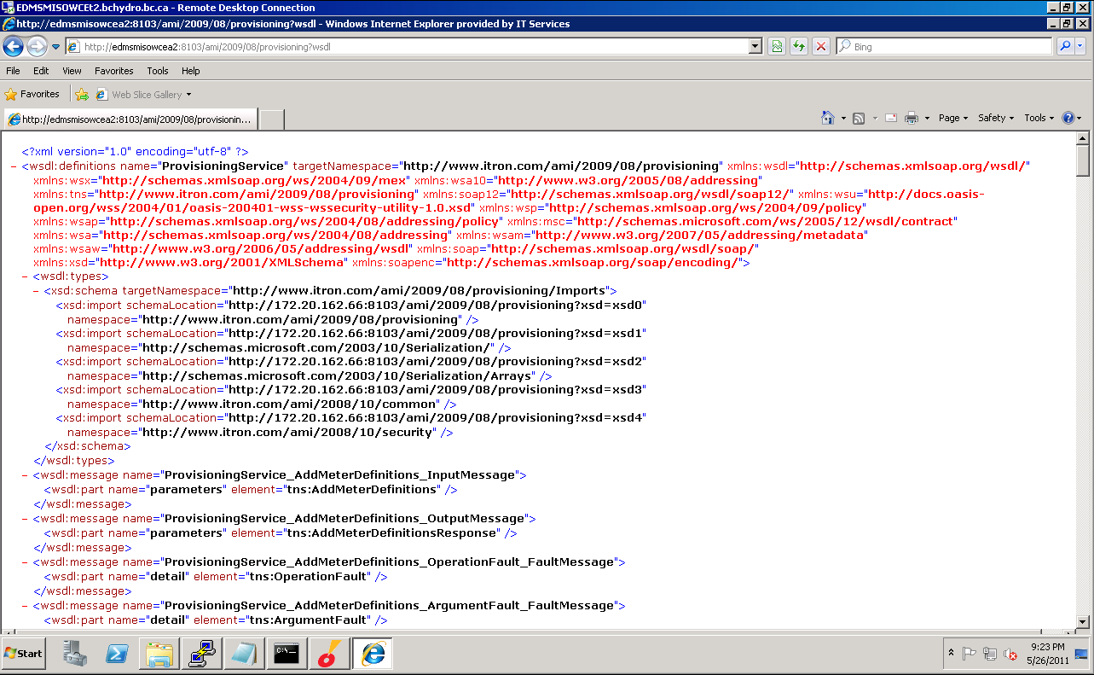
Figure 31 – Provisioning Service WSDL
Request Service WSDL 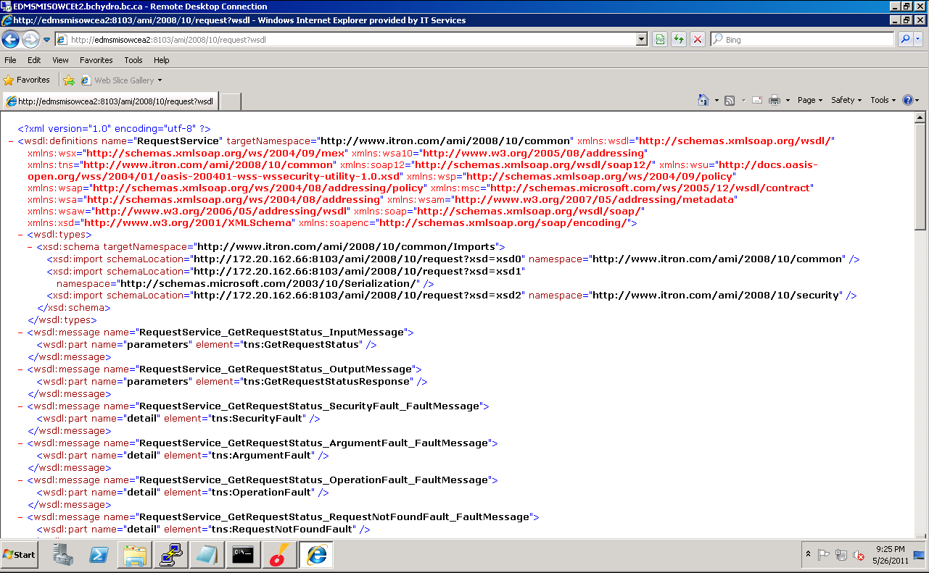
Figure 32 – Request Service WSDL
Reporting Service WSDL
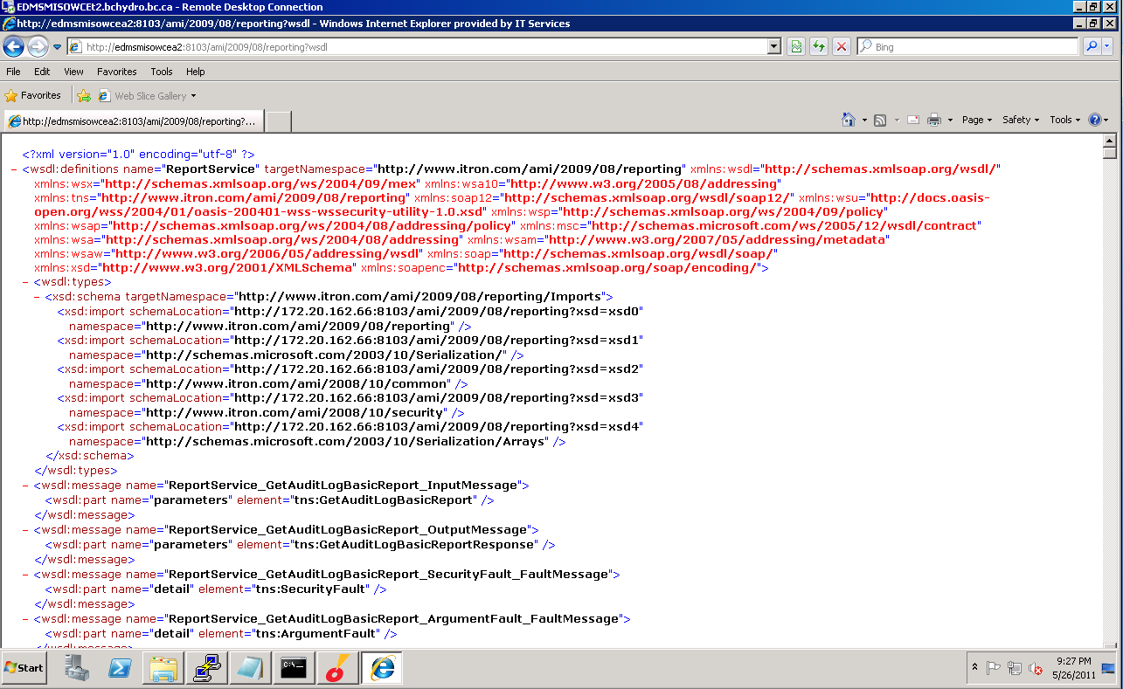
Figure 33 – Reporting Service WSDL
Subscription Service WSDL
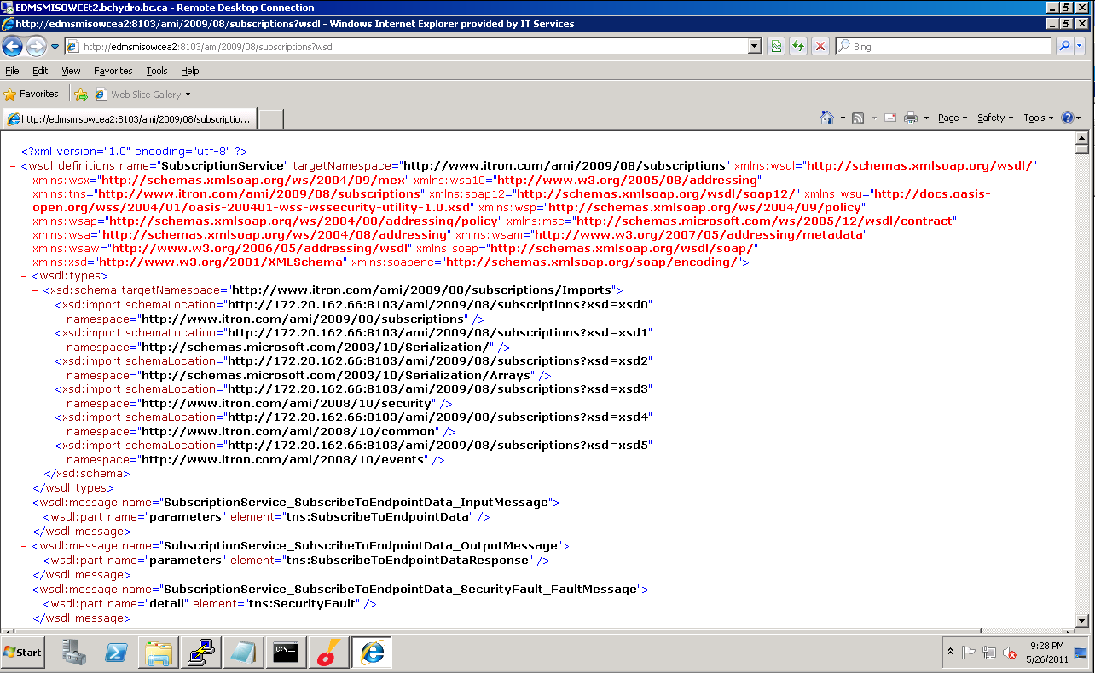
Figure 34 – Subscription Service WSDL
Syslog Validation 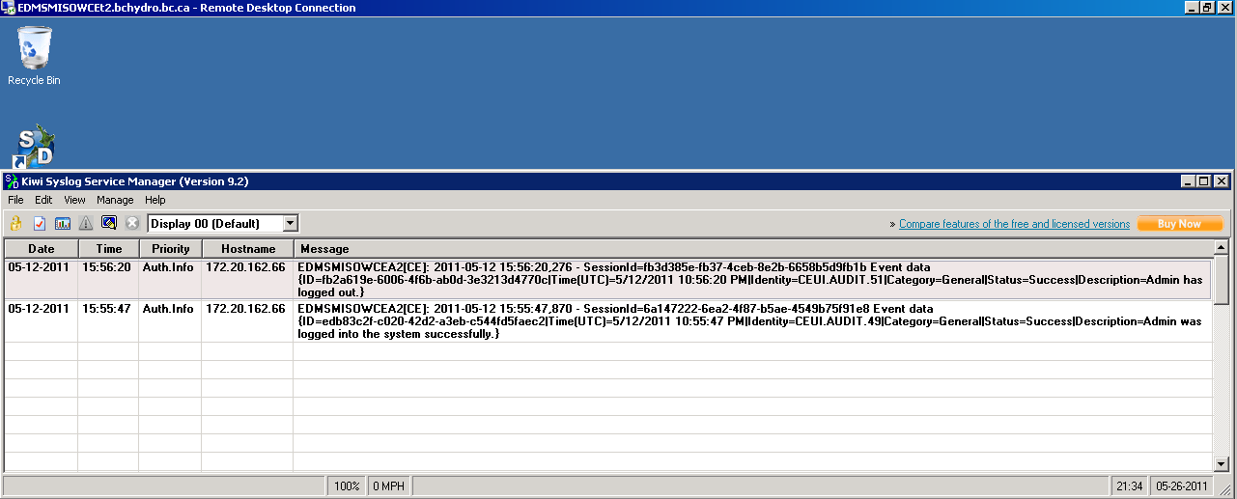
Figure 35 – Syslog

Security Settings

Enhanced Security
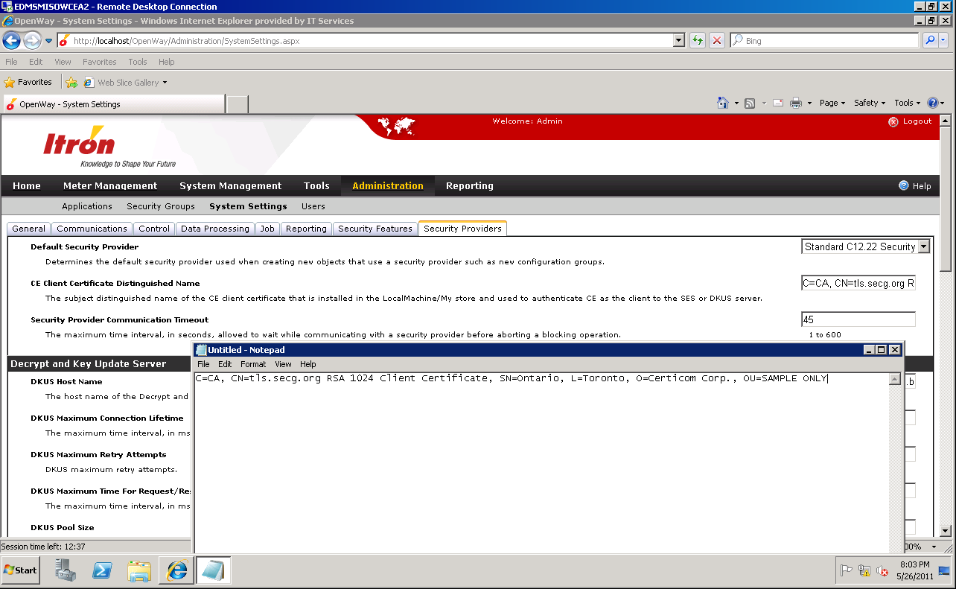
Figure 37 – Enhanced Security Settings
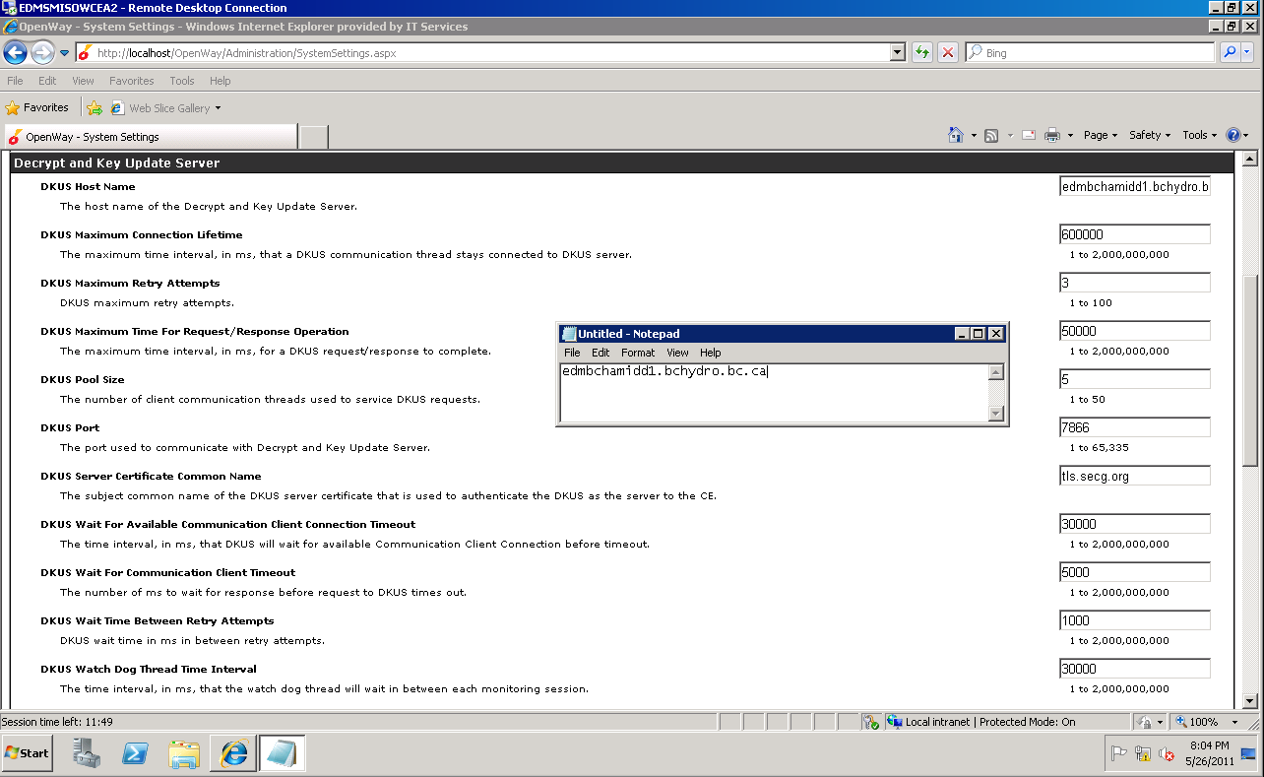
Figure 38 – DKUS Settings
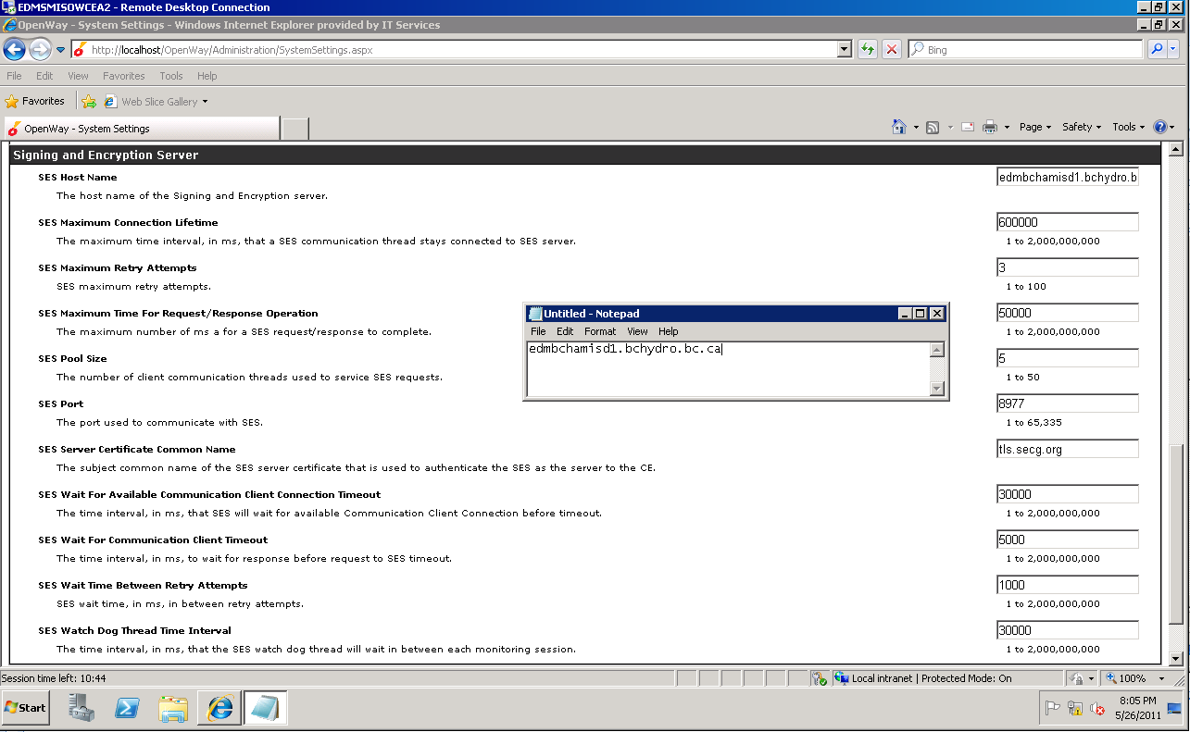
Figure 39 – SES Settings

Meter Passwords
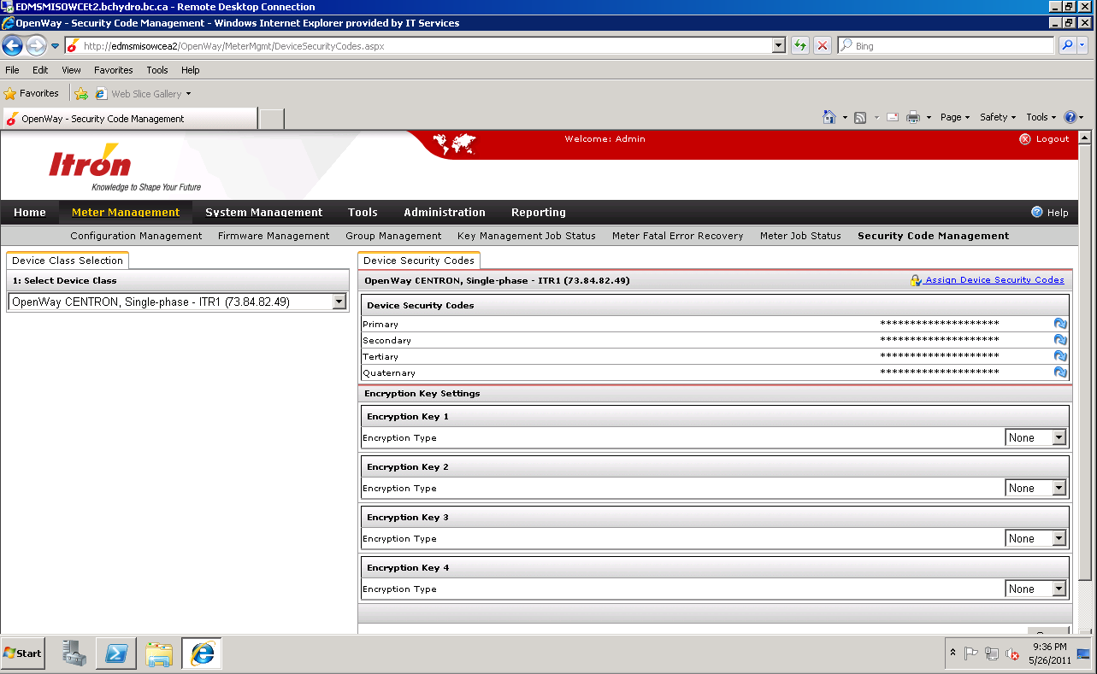
Figure 40 – Meter Password Set (but not displayed)

Users
Default Administrator user
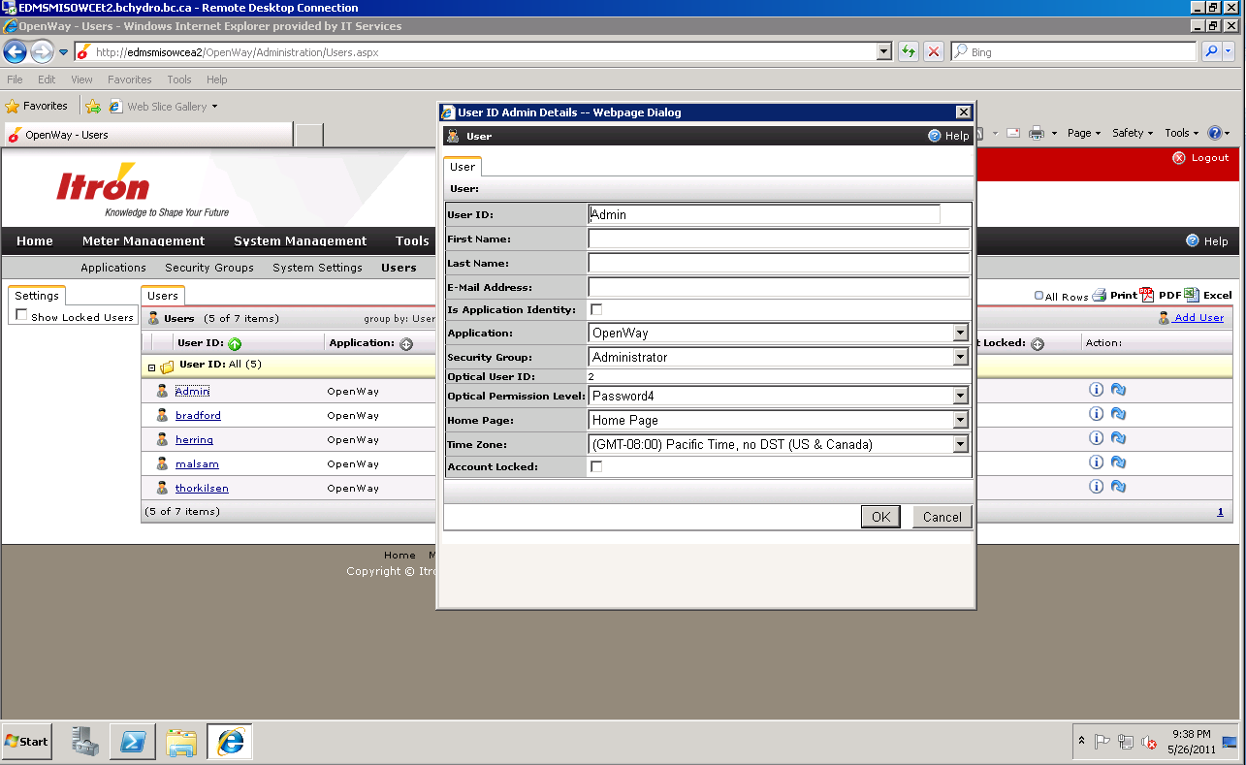
Figure 41 – Admin User

Security Role
The Collection Engine assigns permissions based on security roles for users. The role identifies the system features that will be available for all users who are assigned to the role. An administrator can create, edit, and delete both roles and users.
You must create roles for users before you can assign roles and permissions to users. Permissions selected for a role are available to all users for whom the role is assigned.
Following Security Roles identified for Consumers Energy so far.
    - Administrator - The Collection Engine Administrator role has full permissions to manage Collection Engine Security in addition to various Collection Engine operational functions.
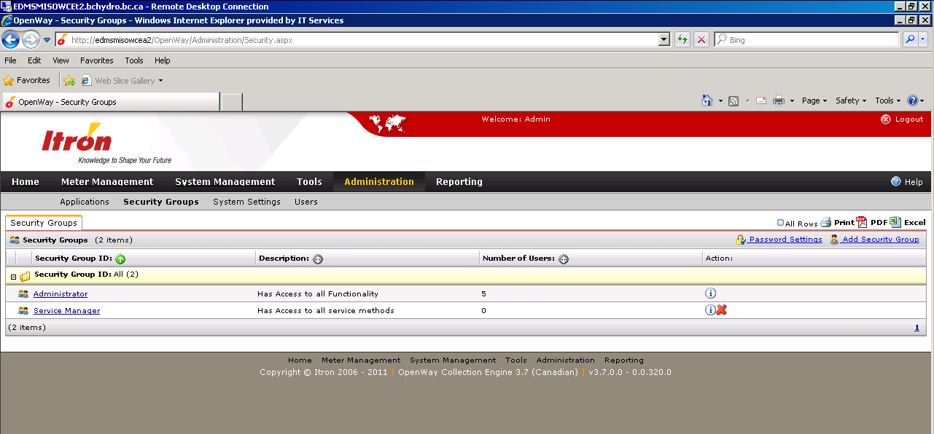
Figure 42 – Groups

HSM Manager Install
Screenshot 1 of 2
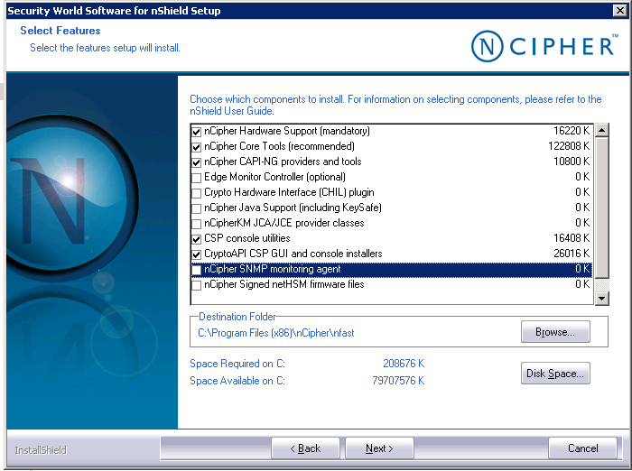

2 of 2
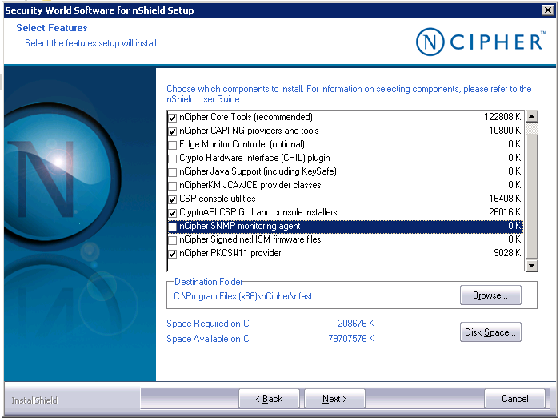

.

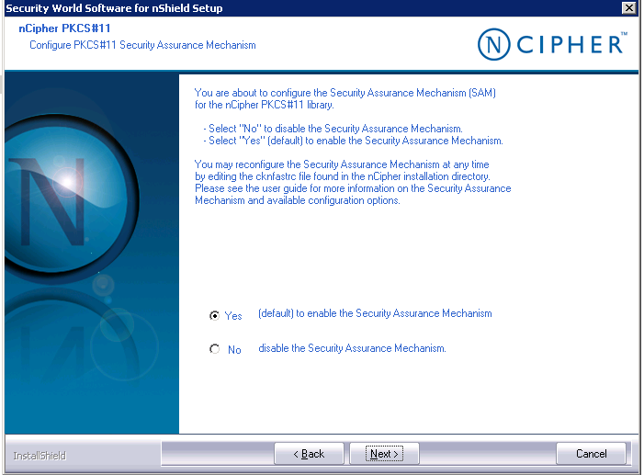

ISM Config:

nCipher CSP Install Wizard
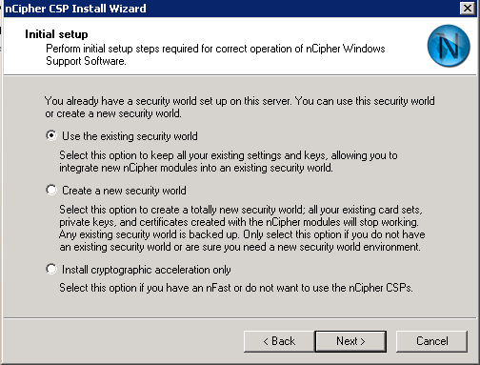
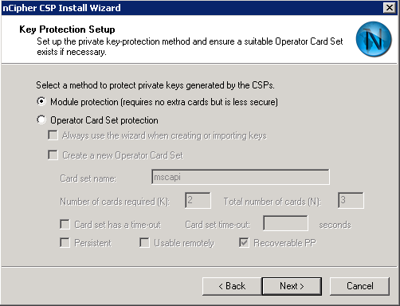

Next until Finish

Itron Security Manager Configuration
PKCS: D:\Program Files (x86)\nCipher\nfast\toolkits\pkcs11\cknfast-64.dll

Database Keys
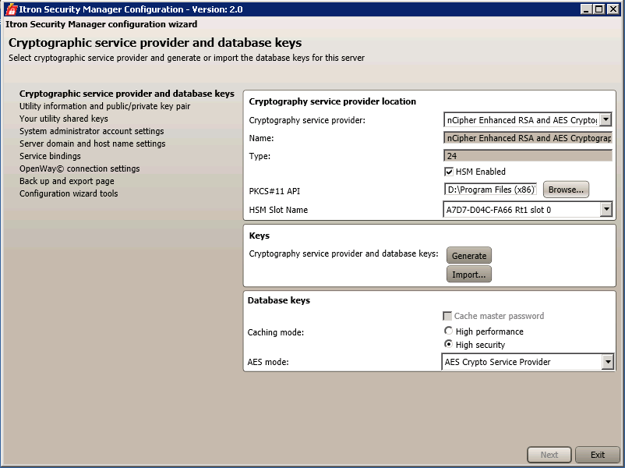
Click Generate.

Create a new Master Password
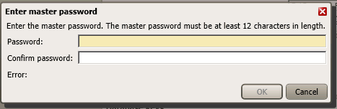

Key Pairs
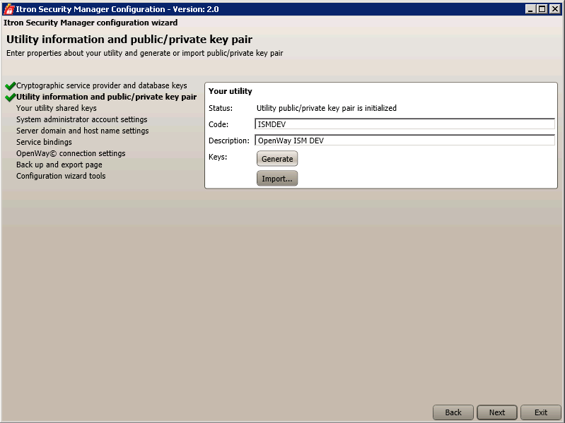

Service Bindings
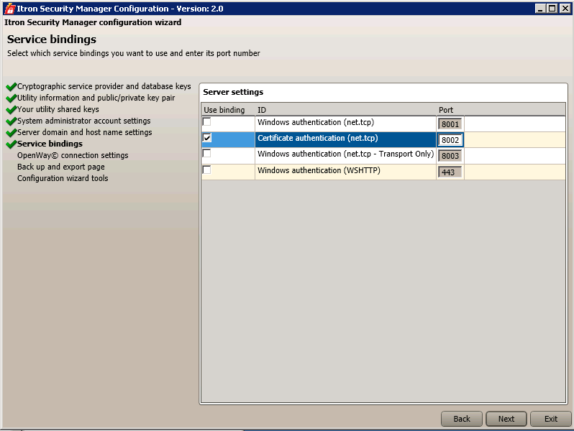

Connections Settings
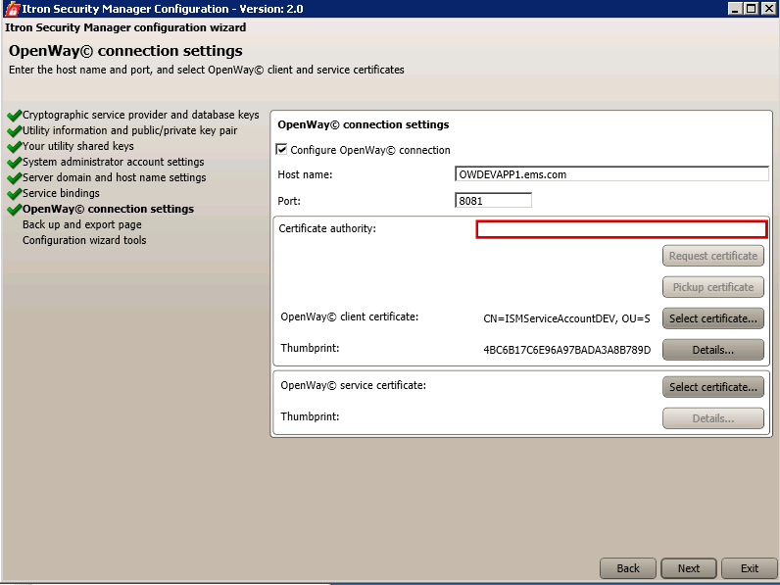

Backup keys
Start service
Export CE Server/ Client Cert to a cer file.
Import/Assign to the ISMExtConn_DEV user in the Itron Security Manager:
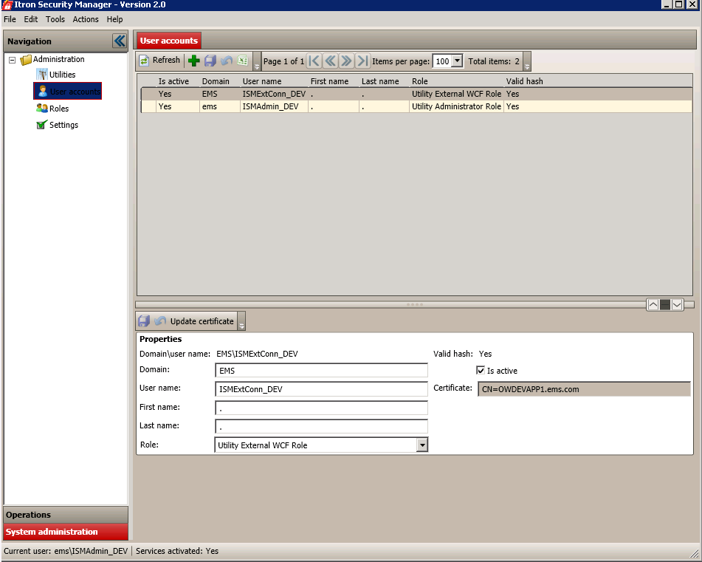

Metadata for Service Instances

Add a Server to the server table.
insert into server (serverkey, hostname, preferredipaddressc1222, preferredipaddressc1222_ipv6) values (101,'OWQAAPP2','0.0.0.0','[::]');

Commit;

Add services to the serviceinstance table

insert into serviceinstance (serviceinstancekey, serverkey, servicetype, instanceid, status) values (101, 101, 'J', 2, 'A');
insert into serviceinstance (serviceinstancekey, serverkey, servicetype, instanceid, status) values (102, 101, 'M', 2, 'S');
insert into serviceinstance (serviceinstancekey, serverkey, servicetype, instanceid, status) values (103, 101, 'R', 2, 'S');
insert into serviceinstance (serviceinstancekey, serverkey, servicetype, instanceid, status) values (104, 101, 'I', 2, 'A');
Commit;

Note: to undo: "rollback;"
SQL> insert into serviceinstance (serviceinstancekey, serverkey, servicetype, in
stanceid, status) values (101, 101, 'J', 2, 'A');
1 row created.

SQL> insert into serviceinstance (serviceinstancekey, serverkey, servicetype, in
stanceid, status) values (102, 101, 'M', 2, 'S');
1 row created.

SQL> insert into serviceinstance (serviceinstancekey, serverkey, servicetype, in
stanceid, status) values (103, 101, 'R', 2, 'S');
1 row created.

SQL> insert into serviceinstance (serviceinstancekey, serverkey, servicetype, in
stanceid, status) values (104, 101, 'I', 2, 'A');
1 row created.

SQL> commit;
Commit complete.
SQL> Select * from serviceinstance;

SERVICEINSTANCEKEY | SERVERKEY | S | INSTANCEID | MCHLOAD | S
1 | 1 | J | 1 |  | A
2 | 1 | M | 1 | 3 | A
3 | 1 | R | 1 |  | A
4 | 1 | I | 1 |  | A
101 | 101 | J | 2 |  | A
102 | 101 | M | 2 |  | S
103 | 101 | R | 2 |  | S
104 | 101 | I | 2 |  | A

Open Issues and Questions
 |  |  |  | Date
# | Description | Raised By | Assigned To | Created | Due | Resolution
1
2
3
4
5
6
7
8
9
10

